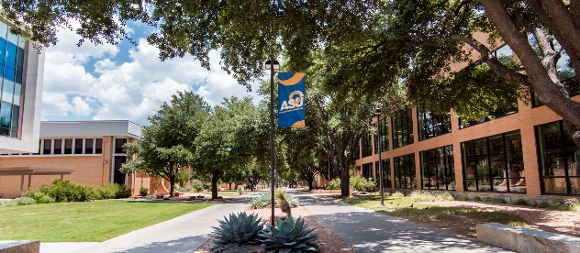

System Analysis and Design Report

***REPORT TITLE:***

***Online Application***

***&***

***Student Management System***

Online Application & Student Management System  
Angelo State University

BSc (Hons) Software Engineering  
System Analysis and Design  
Year 2 Semester 1

Mr J. Narsoo

Prepared By: Lovena Ujoodha 2110_22856

jr

Ishwari Veeraragoo 2110_22858

jr

Submission Date: 14 February 2023

**Module Name: System Analysis & Design**

**Student Names**: **VEERARAGOO Ishwari**

**(ID: 2110_22858)**

**&**

**UJOODHA Lovena**

**(ID: 2110_22856)**

**Table of Contents:**

**Table of Contents**

1. Introduction 3

1.1 System Analysis 3

1.2 System Design 4

2. Preliminary investigation 4

**2.1 Study of existing system 4**

**2.2 The Interview 4**

**2.3 Proposed System 5**

3. Feasibility Study 5

**3.1 Technical feasibility 5**

**3.2 Economic feasibility 5**

**3.3 Operational Feasibility 6**

4. List of features 7

5. UML Diagrams 8

**5.1 Introduction 8**

**5.2 Case Diagrams & Use Case Specifications 8**

**5.2.1 Student 8**

**5.2.2 Programme 10**

**5.2.3 Module 12**

**5.2.4 Cohort 14**

**5.2.5 Lecturer 16**

**5.2.6 Coursework 18**

**5.2.7 Exam 21**

**5.2.8 Work Placement 24**

**5.2.9 Project 26**

**5.2.10 Moderation 30**

**5.2.11 Board of Examiners 31**

**5.2.12 Generate 33**

**5.2.13 Attendance 34**

**5.2.14 Account 36**

**5.2.15 Admission 38**

**5.3 Sequence Diagram 41**

6. Database Design 42

**6.1 Table Student 42**

**6.2 Table Programme 43**

**6.3 Table Programme Coordinator 43**

**6.4 Table Module 44**

**6.5 Table Module Coordinator 45**

**6.6 Table Cohort 45**

**6.7 Table Lecturer 46**

**6.8 Table Coursework 46**

**6.9 Table Re-sit Coursework 47**

**6.10 Table Exam 47**

**6.11 Table Re-sit Exam 48**

**6.12 Table Project 48**

**6.13 Table Re-sit Project 49**

**6.14 Table Work Placement 49**

**6.15 Table Board of Examiners 50**

**6.16 Table Result 50**

**6.17 Table Attendance 51**

**6.18 Table Account 51**

**6.19 Table Applicant 52**

**6.20 Table Admission 52**

**6.21 Table Payment 53**

7. Input and output Designs 54

**7.1 Registration 54**

**7.2 Login 55**

**7.3 Admission 56**

**7.4 Coursework 59**

8. Testing 60

**8.1 White Box Testing 60**

**8.2 Black Box Testing 61**

**8.3 Unit Testing 61**

**8.4 Integration Testing 61**

9. Test Cases 61

**9.1 Registration form: 61**

**Test Case: First Name 61**

**Test Case: Last Name 62**

**Test Case: Phone Number 62**

**Test Case: Email 62**

**Test Case: Password 63**

**Test Case: Upload Birth Certificate 63**

10. Gantt Chart 64

11. Conclusion 64

# **1. Introduction**

A student management system also known as student information management system is a software which gives a helping hand for educational institutions to coordinate their students’ data securely. It encapsulates features such as grading, attendance tracking and many more. Many educational establishments are implementing this new system to computerize their administrative processes and to enable better communication with their students. Moreover, this concept eases the lives of students’ since it provides simple and clear data input methods, accessibility as well as end to end functionality. Additionally, SIS is very eco-friendly as tree do not need to be cut to record paper-based data.

# **1.1 System Analysis**

System analysis is a thorough examination of the numerous tasks carried out by a system and the connections between those tasks both inside and outside the system. It entails investigating and evaluating how a company now generates information by processing data.

Data was gathered during study on the numerous files, decision-making processes, and transactions handled by the current system. The system's effectiveness mostly depends on how precisely the problem is stated, how thoroughly it is examined, and how well the solution chosen is implemented. A good analysis model should offer both the framework for the solution and the methods for comprehending the problem. As a result, it needs to be thoroughly investigated by gathering system data. The suggested system should then be carefully examined considering the requirements.

System analysis can be categorized into four parts.

* + - System planning and initial investigation
    - Information Gathering
    - Applying analysis tools for structured analysis
    - Feasibility study
    - Cost/ Benefit analysis.

# **1.2 System Design**

The process of translating requirements into a software representation is known as system design. At first, the depiction shows a comprehensive picture of software. A design representation that is extremely like source code results from further refining. Design is an area of software development where quality is promoted. The only way to accurately translate customer needs into a finished software product or system is through design, which gives us a representation of software that can be evaluated for quality. All subsequent processes in software engineering and maintenance are built upon the foundation provided by system design.

# **2. Preliminary investigation**

## **2.1 Study of existing system**

In the current system we need to keep several records related to the students and applicants want to enter the details of the student, and the applicant manually. Only a teacher or the school authority can view the mark of the student, and they want to input the details of the student. This procedure takes too much time and is costly.

Today in university student details are entered manually. To keep each students’ details in a specific and separate record is not an easy task and as a result there can be a risk for manual errors.

* + - 1. When the student comes in university.
      2. First, he/she takes admission form from reception.
      3. Fills it and submits it into office.
      4. Filled form is first checked with documents like merit list a details came from university and verified by an official person, if there is any mistake then it is corrected.
      5. At the time of submission of it the fees are deposited by the candidate.
      6. At the time of submission of admission forms admission ID is assigned to the candidate by the university.
      7. Candidate gets the receipt of fees deposition.
      8. Enter details of students
      9. Enter students’ grades
      10. Manage programmes and modules
      11. Manage cohorts and attendance

Disadvantages of Current System: -

1. Require much manpower i.e., many efforts, much cost and hard to operate and maintain.
2. Since, all the work is done in papers, so it is very hard to locate a particular student record when it is required.
3. It is time consuming.

## **2.2 The Interview**

We have carried out an interview whereby we have asked the interviewee a series of prepared questions so that we can have a better and clear understanding of the university’s functionality.

**Interview guide:**

|  |  |
| --- | --- |
| **Interviewee**: Mr Thomas Franklin (Owner of the University of Angelo) | **Interviewer**: Ujoodha Lovena  Veeraragoo Ishwari |
| **Location / Medium**: Through a video meeting on Skype | **Appointment Date**: 05th December 2022  Start Time: 18:30  End Time: 19:30 |
| **Main objective**: To have a clear understanding about the university’s daily operations (administrative and in class) | **Important reminders**:  Admission process  Management of students’ data |

|  |  |
| --- | --- |
| **Agenda** | **Duration** |
| Introduction | 1 minute |
| Background on Project | 2 minutes |
| Overview of Interview  Topics to be covered  Request permission to record | 1 minute |
| What are the services of education your university provide? | 5 minutes |
| How does the university manage students and applicants’ records? | 10 minutes |
| What are some of the drawbacks you/ your employees have come across on a daily basis? | 5-10 minutes |
| Have you ever thought of some solutions. Elaborate, if yes | 5 minutes |
| Why do you want us to computerize this system? | 5 minutes |
| What are your overall expectations of the computerized system? | 5 minutes |
| Summary of major points | 2-5 minutes |
| Open questions from interviewee | 2-5 minutes |
| Closing | 1 minute |

|  |  |
| --- | --- |
| **Questions** | **Answers** |
| 1. When was the university established and first accessible to students? | 18th November 1928 |
| 1. Approximately how many students enroll to your university yearly? | Approximately 5000 students but we get new numbers each year |
| 1. What is the usual the procedure for an admission? | Firstly, the applicant takes a form the reception, fills it and then submit it to the office. The filled form is then checked by a person to see if there are any error and if the applicant is eligible for his/her chosen course. |
| 1. How are the attendance of students recorded? | The attendance is recorded by the lecturer and each individual student have to sign in a hardcopy book. |
| 1. How are the results of students proclaimed? | For each students their marks for a particular module are recorded in a hardcopy book. Once all marks are checked by a university authority, the GPA is calculated and then generate a hardcopy transcript and give it to the respective student. |
| 1. How are the records/ details of the students managed? | The details of students are recorded in a hardcopy book |
| 1. What is the procedure for the students when they pay for their semester fees? | They have to collect a cash deposit voucher from the office and deposit the cash through the bank. However, we now offer internet banking, so they can make the transaction online |
| 1. What happens when you have to make a modification in the record of one student? | We change the details with some correction fluid and a pen. We also have to make sure we have updated the details other places also so as to avoid any confusion |
| 1. What are some of the drawbacks you/ your employees have come across on a daily basis? | Very often we have made some errors while performing data entry during the registration process. We also find that our way of managing students’ records is very exhausting and time consuming. |
| 1. Have you ever thought of some solutions, besides computerizing the system Elaborate, if yes | Not really |
| 1. Why do you want us to computerize this system? | Mainly to have a proper control of the university which also includes administrative work. Also, each year the number of students enrolling in our university keeps on increasing and hence to manage all their data is tedious task! |
| 1. What are your overall expectations of the computerized system? | We would like to have a software system where we can manage students’ data, results. Also, we want the system accessible to students, lecturer, programme coordinator and module coordinator as well. So that for example our lecturer can post assignments and coursework and students can easily view it. This system management will be very helpful especially during this pandemic situation. |

## **2.3 Proposed System**

In our proposed system we have the idea for adding the required details of the students by themselves. So, the overhead of the school authorities and the lecturers is becoming less. Another major con of the system is that it is very simple to modify the details as well as delete with clear instructions given throughout the system. The marks of the student are added in the database and so students can also view the marks for each module whenever they want. The system is also to automate the process carried out in the organization with improved performance and realize the vision of paperless admission. Programme coordinator and module coordinator can update details of modules and programmes whenever they want.

Our proposed system has several advantages: -

* User friendly interface
* Fast access to database
* Less error
* More Storage Capacity
* Search facility
* Look and Feel Environment
* Quick transaction

# **3. Feasibility Study**

The conduction of a feasibility study plays a very crucial role in the proper development of a software system. It helps us to acknowledge the fact that whether the developing software will be feasible or not. Feasibility study is divided into three categories namely, economic feasibility, technical feasibility, and lastly operational feasibility. By going through these three steps, the management will be much more convinced if the project is worth or that it will be just a waste of time.

For our project, the online application and student management system, we will focus more on the technical and economic feasibility study.

## **3.1 Technical feasibility**

According to our project we can firmly say that it is technically feasible and here is why. First and foremost, we will not have the issue of getting the resources required for the development of the software since almost all of them are already available by the client and are in good conditions.

Below are the hardware and system requirements as well as some additional tools that our system will need.

**Hardware Requirements:**

|  |  |
| --- | --- |
| Processor | Intel P-IV System |
| RAM | 128 MB |
| Hard disk | 20 GB |
| Ethernet Connection | Wireless Adapter (Wi-Fi); 15 mbps |
| Processor Speed | Minimum 250 MHz |

**Software Requirements:**

|  |  |
| --- | --- |
| Operating System | Microsoft Windows / Mac OS/ Linux OS |
| Language | Java/ C++ |
| Database | My SQL |

**Additional tools:**

* HTML
* CSS
* Visual Studio / NetBeans

## 

## **3.2 Economic feasibility**

The economic feasibility relates mainly to the cost involved for the proposed solutions and the potential benefits in terms of tangible and intangible, it can bring to the project. The economic feasibility seems to be very blooming for our system. First, only a reasonable amount of fund is required for its development, since we are using resources which are already available. However, an additional task to be done is a proper environment with a well inspected supervision. This will help to attain maximum usability of the resources. Additionally, after the development of the project, the client will have to have to do proper maintenance of the software and hardware equipment to keep in good condition.

**Intangible benefits the organization will encounter:**

* More timely information
* Better and modern design interface hence increase satisfaction of users
* Much better initiative (going green)
* Much better organizational planning

**One time cost details:**

|  |  |
| --- | --- |
| Development Cost | Rs 110,000 |
| Existing Resources  (Hardware/ Software) | Rs 30,000 |
| User Training | Rs 4,000 |
| **Total-Cost** | **Rs 144,000** |

**Tangible Benefits**

|  |  |
| --- | --- |
| Cost reduction or avoidance | Rs 20,000 |
| Increase speed of activity | Rs 200,000 |
| Improve in management planning | Rs 140,000 |
| **Total-Cost** | **Rs 360,000** |

## **3.3 Operational Feasibility**

Operational feasibility refers to what extend does the proposed system, solves the problems that may arise. Our system is a very modern looking and interactive interface with soothing colors, which as a result will make any system user feel more comfortable and easier to work into. Furthermore, the system helps the user to have a much better user experience. We also provide clear and simple instructions on the system to encourage error-free data entry. Throughout our system we have tried to keep minimum mouse clicks to make it have a more professional pace.

# **4. List of features**

|  |  |
| --- | --- |
| **Use Case** | **Actor** |
| Add Student | Administrator |
| Update Student | Administrator |
| Delete Student | Administrator |
| Search Student by Id, Names | Administrator, Lecturer |
| Add Programme | Programme Coordinator |
| Update Programme | Programme Coordinator |
| Delete Programme | Programme Coordinator |
| Search Programme by Name, Id, Module | Student, Programme Coordinator, Lecturer |
| Add Module | Module Coordinator |
| Update Module | Module Coordinator |
| Delete Module | Module Coordinator |
| Search Module by Name, Programme | Programme Coordinator, Module Coordinator, Student, Lecturer |
| Add Cohort | Programme Coordinator |
| Update Cohort | Programme Coordinator |
| Delete Cohort | Programme Coordinator |
| Search Cohort by Id, name, Student Name | Programme Coordinator |
| Add Lecturer | Module Coordinator |
| Update Lecturer | Module Coordinator |
| Delete Lecturer | Module Coordinator |
| Search Lecturer by Names, Module, Programmes | Student, Module Coordinator, Programme Coordinator |
| Add Coursework | Lecturer, Module Coordinator |
| Update Coursework | Lecturer, Module Coordinator |
| Delete Coursework | Lecturer, Module Coordinator |
| Search Coursework by date, Description, Lecturer, Student | Module Coordinator, lecturer |
| Add Resit Coursework | Lecturer, Module Coordinator |
| Update Resit Coursework | Lecturer, Module Coordinator |
| Delete Resit Coursework | Lecturer, Module Coordinator |
| Search Resit Coursework by date, Description, Lecturer, Student | Lecturer, Module Coordinator, |
| Add Exam | Faculties |
| Update Exam | Faculties |
| Delete Exam | Faculties |
| Search Exam by Date, Module, Student, Programme, Cohort | Students, Module Coordinator |
| Add Resit Exam | Module Coordinator, Programme Coordinator |
| Update Resit Exam | Module Coordinator, Programme Coordinator |
| Delete Resit Exam | Module Coordinator, Programme Coordinator |
| Search Resit Exam by Date, Module, Student, Programme, Cohort | Module Coordinator, Programme Coordinator, Students |
| Add Work Placement | Programme Coordinator |
| Update Work Placement | Programme Coordinator |
| Delete Work Placement | Programme Coordinator |
| Search Work Placement | Programme Coordinator |
| Add Project | Module Coordinator, Lecturer |
| Update Project | Module Coordinator, Lecturer |
| Delete Project | Module Coordinator, Lecturer |
| Search Project | Module Coordinator, Lecturer |
| Post Coursework | Module Coordinator, Lecturer |
| Post Exam | Module Coordinator, Lecturer |
| Post Project | Module Coordinator, Lecturer |
| Un-post Coursework | Module Coordinator, Lecturer |
| Un-post Exam | Module Coordinator |
| Un-post Project | Module Coordinator, Lecturer |
| Moderate Coursework | Lecturer, Module Coordinator |
| Moderate Examination | Module Coordinator |
| Moderate Project | Module Coordinator, Lecturer |
| Generate Board of Examiners Report | Programme Coordinator |
| Update Exam after BOE | Module Coordinator |
| Update Project after BOE | Module Coordinator |
| Update Coursework after BOE | Module Coordinator |
| Generate Result | Faculties |
| Check Result by Student | Faculties |
| Generate Transcript | Faculties |
| Add attendance | Lecturer |
| Update attendance | Lecturer |
| Delete attendance | Lecturer |
| Search attendance by students' ID | Lecturer, Module Coordinator |
| Create Account | Student, Administrator, Lecturer, Programme Coordinator, Module  Coordinator, Applicant |
| Manage registration | Administrator |
| View admission | Applicant, Administrator |
| Update admission | Applicant |
| Manage fees | Administrator |
| Change account password | Administrator, Students, Applicants, Lecturer, Programme  Coordinator, Module Coordinator |
| Make payments | Students, Applicants |
| Upload scanned documents | Students, Applicants |
| Verify admission | Applicant |
| Merit status tracking | Applicant |
| Confirm admission | Applicant |
| Compare qualify scores | Administrator |
| Merit list | Administrator, Applicant |

# **5. UML Diagrams**

## **5.1 Introduction**

An engineering system or product's initial development phase stage is its design. In software development, quality is promoted through design. Only via design will we be able to faithfully transform user needs into a finished software product or system. All subsequent phases involving software engineers and maintenance have their roots in software design. Without design, we run the danger of creating an unstable design that will break down when minor adjustments are made, may be challenging to test, and whose number will not be known until late in the software engineering process.

We have created Unified Modelling Language (UML) diagrams using the software requirements specification document from the analysis phase as input to the design phase. UML is dependent on system visual modelling. Visual modelling is the technique of employing a standardized set of graphical elements to represent the information from the model graphically.

The Star UML Diagrammed Software is used to create UML diagrams. When complexity is presented to us visually rather than textually, we tend to be able to comprehend it better. A system's various levels of operation can be demonstrated by creating graphic representations of the system. The interactions between users and the system are subject to modelling.

## **5.2 Case Diagrams & Use Case Specifications**

Use Case Diagram displays the relationship among actors and use cases.

### **5.2.1 Student**

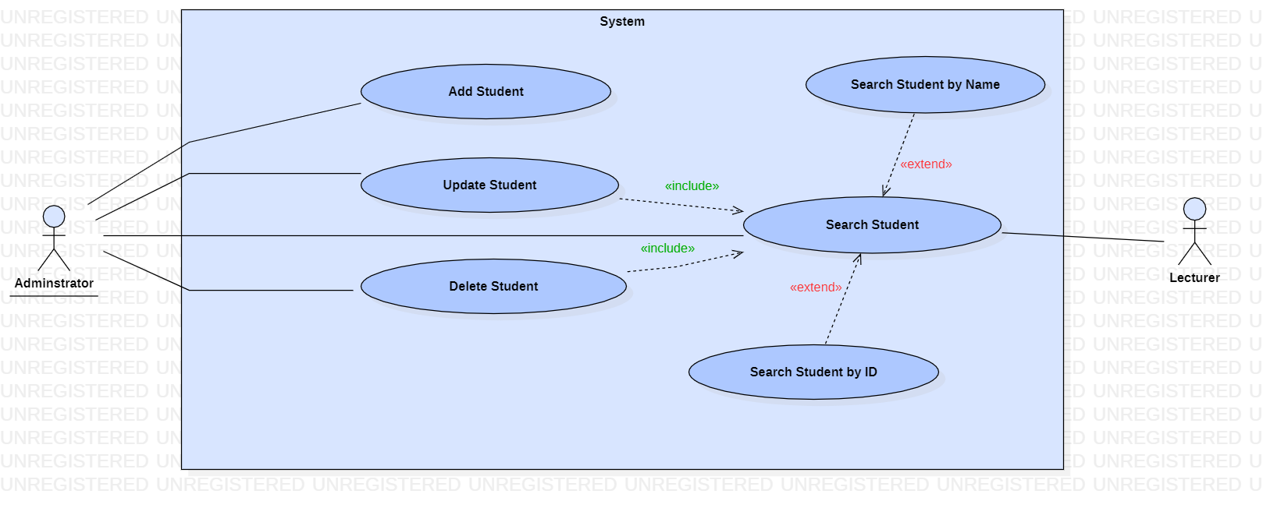

|  |  |
| --- | --- |
| **Use case name:** Add Student | |
| **Participating actors(s):** Admin | |
| **Preconditions:** Before the use case starts, the admin must log in the system. | |
| **Flow of events** | |
| **Actor Action** | **System Response** |
| 1. Enters student’s details.  3. Actor confirms the details and save. | 2. Validates if data have been typed in the correct format and allow actor to confirm the details.  4. Displays a confirming message that student has been added. |
| **Postconditions:** Student has been added successfully. | |
| **Special Requirements:** None | |

|  |  |
| --- | --- |
| **Use case name:** UpdateStudent | |
| **Participating actors(s):** Admin | |
| **Preconditions:** Before the use case starts, the admin must log in the system and then search for the student before proceeding with the update | |
| **Flow of events** | |
| **Actor Action** | **System Response** |
| 1. Enters the student ID and name.  3. Updates the required data and save. | 2. Displays the student details.  4. Presents a message confirming update. |
| **Postconditions:** Student has been updated successfully | |
| **Special Requirements:** None | |

|  |  |
| --- | --- |
| **Use case name:** DeleteStudent | |
| **Participating actors(s):** Admin | |
| **Preconditions:** Before the use case starts, the admin must log in the system and then search for the student before proceeding with the deletion | |
| **Flow of events** | |
| **Actor Action** | **System Response** |
| 1. Enter student ID and name.  3. Selects delete. | 2. Retrieves the data, display student’s details and allow actor to delete.  4. Displays a confirming delete verification dialog. |
| **Postconditions:** Student has been deleted successfully | |
| **Special Requirements:** None | |

|  |  |
| --- | --- |
| **Use case name:** Search Student | |
| **Participating actors(s):** Admin, Lecturer | |
| **Preconditions:** Before the use case starts, admin and lecturer must log in the system. | |
| **Flow of events** | |
| **Actor Action** | **System Response** |
| 1. Enter student ID / name  3. The use case ends when the actor finds the student | 2. Retrieves and displays the data if it exists. |
| **Postconditions:**  The actors successfully find the respective student they are looking for. | |
| **Special Requirements:** Actors can either search student by name or ID at a time | |

### **5.2.2 Programme**

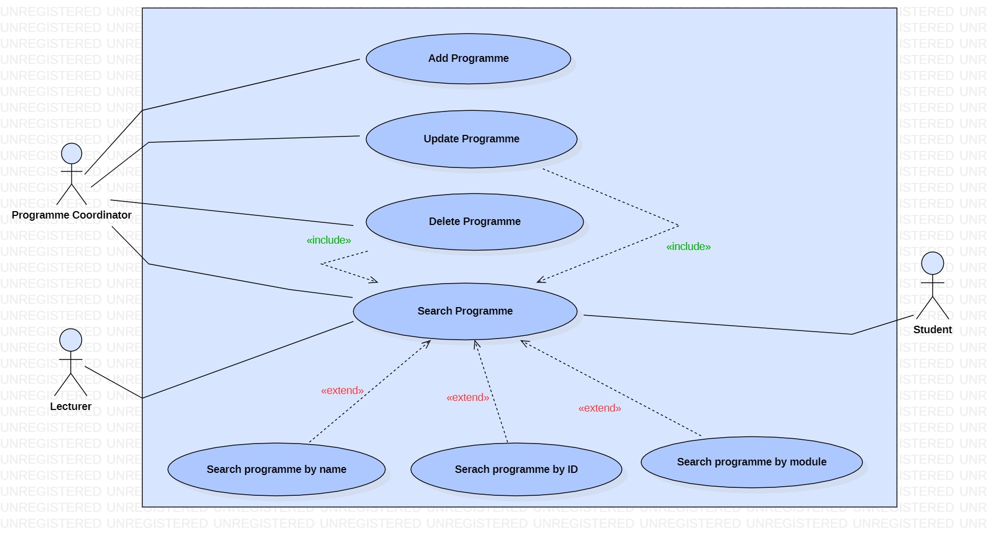

|  |  |
| --- | --- |
| **Use case name:** Add programme | |
| **Participating actors(s):** Programme Coordinator | |
| **Preconditions:** Before the use case starts, actor must log in the system | |
| **Flow of events** | |
| **Actor Action** | **System Response** |
| 1. Enter the programme’s details  3. Actor confirms the details and save | 2. Validates if data have been typed in the correct format and allow actor to confirm the details.  4. Displays a confirming message that programme has been added. |
| **Postconditions:** Programmehas been added successfully | |
| **Special Requirements:** None | |

|  |  |
| --- | --- |
| **Use case name:** Update programme | |
| **Participating actors(s):** Programme Coordinator | |
| **Preconditions:** Before the use case starts, actor must log in the system and then search for the programme before proceeding with the update | |
| **Flow of events** | |
| **Actor Action** | **System Response** |
| 1. Enter the programme’s details  3. Allow the actor to update the required data and save. | 2. Retrieves and displays the programme’s details  4. Displays a confirming message that programme has been updated. |
| **Postconditions:** Programmehas been updated successfully | |
| **Special Requirements:** None | |

|  |  |
| --- | --- |
| **Use case name:** Delete Programme | |
| **Participating actors(s):** Programme Coordinator | |
| **Preconditions:** Before the use case starts, the actor must log in the system and then actor must search for the programme before proceeding with the deletion | |
| **Flow of events** | |
| **Actor Action** | **System Response** |
| 1. Enter programme’s details.  3. Selects delete. | 2. Retrieves the data, display programme’s details and allow actor to delete.  4. Displays a confirming delete verification dialog. |
| **Postconditions:** Programme has been deleted successfully | |
| **Special Requirements:** None | |

|  |  |
| --- | --- |
| **Use case name:** Search Programme | |
| **Participating actors(s):** Programme coordinator, lecturer, student | |
| **Preconditions:** Before the use case starts, actors must log in the system. | |
| **Flow of events** | |
| **Actor Action** | **System Response** |
| 1. Enter programme’s ID/ name/module  3. The use case ends when the actors find the programme | 2. Retrieves and displays the data if it exists. |
| **Postconditions:**  The actors successfully find the programme they are looking for. | |
| **Special Requirements:** Actors can eithersearch programme by name/ID/module at a time | |

### **5.2.3 Module**

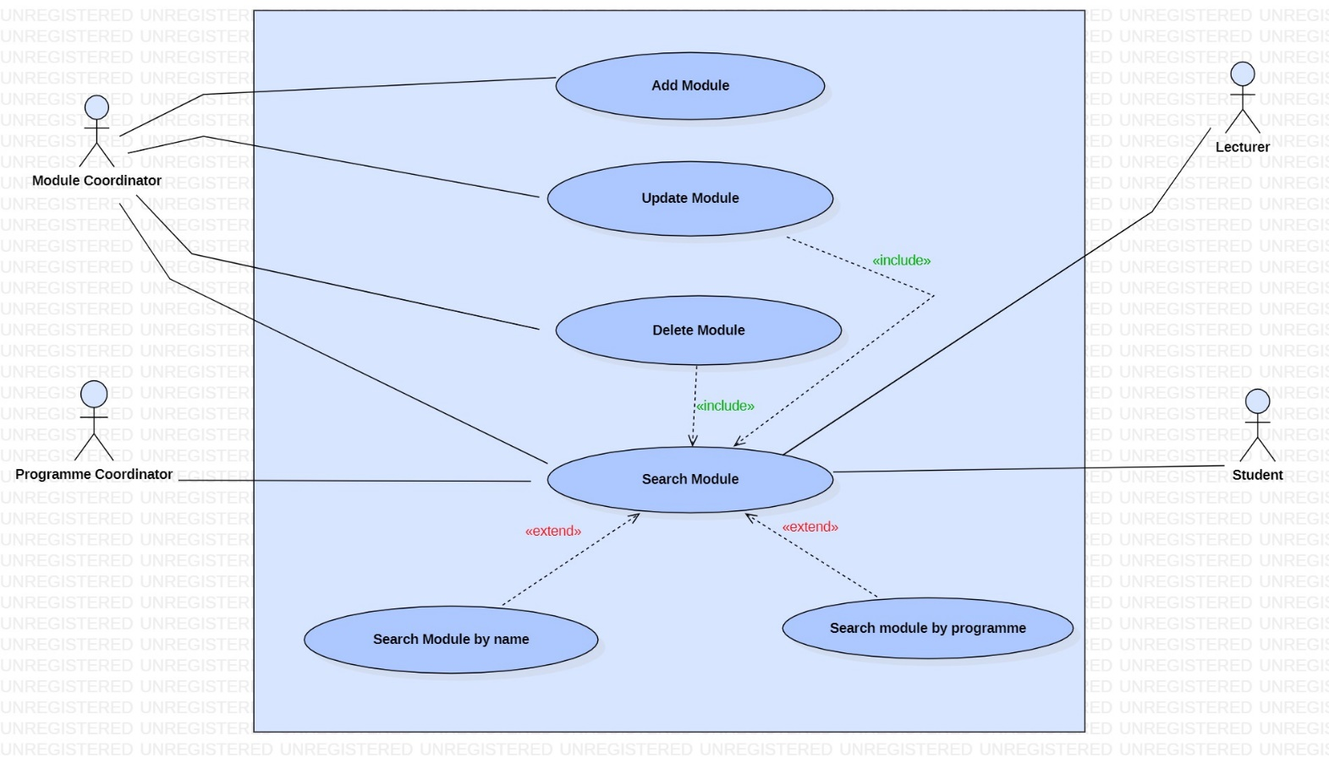

|  |  |
| --- | --- |
| **Use case name:** Add Module | |
| **Participating actors(s):** Module Coordinator | |
| **Preconditions:** Before the use case starts, actor must log in the system | |
| **Flow of events** | |
| **Actor Action** | **System Response** |
| 1. Enter the module’s details  3. Actor confirms the details and save | 2. Validates if data have been typed in the correct format and allow actor to confirm the details.  4. Displays a confirming message that module has been added. |
| **Postconditions:** Programmehas been added successfully | |
| **Special Requirements:** None | |

|  |  |
| --- | --- |
| **Use case name:** Update module | |
| **Participating actors(s):** Module Coordinator | |
| **Preconditions:** Before the use case starts, actor must log in the system and then actor must search for the module first before proceeding with the update | |
| **Flow of events** | |
| **Actor Action** | **System Response** |
| 1. Enter the module’s details  3. Allow the actor to update the required data and save. | 2. Retrieves and displays the module’s details  4. Displays a confirming message that module has been updated. |
| **Postconditions:** Programmehas been updated successfully | |
| **Special Requirements:** None | |
|  | |

|  |  |
| --- | --- |
| **Use case name:** Delete Module | |
| **Participating actors(s):** Module Coordinator | |
| **Preconditions:** Before the use case starts, the actor must log in the system and then search for the module before proceeding with the deletion | |
| **Flow of events** | |
| **Actor Action** | **System Response** |
| 1. Enter module’s details.  3. Selects delete. | 2. Retrieves the data, display module’s details and allow actor to delete.  4. Displays a confirming delete verification dialog. |
| **Postconditions:** Module has been deleted successfully | |
| **Special Requirements:** none | |

|  |  |
| --- | --- |
| **Use case name:** Search Module | |
| **Participating actors(s):** Module Coordinator, Programme Coordinator, Lecturer, Students | |
| **Preconditions:** Before the use case starts, actors must log in the system. | |
| **Flow of events** | |
| **Actor Action** | **System Response** |
| 1. Enter module’s name/programme  3. The use case ends when the actors find the module | 2. Retrieves and displays the data if it exists. |
| **Postconditions:**  The actors successfully find the programme they are looking for. | |
| **Special Requirements:** Actors can eithersearch the module by its name or programme at a time. | |

### **5.2.4 Cohort**

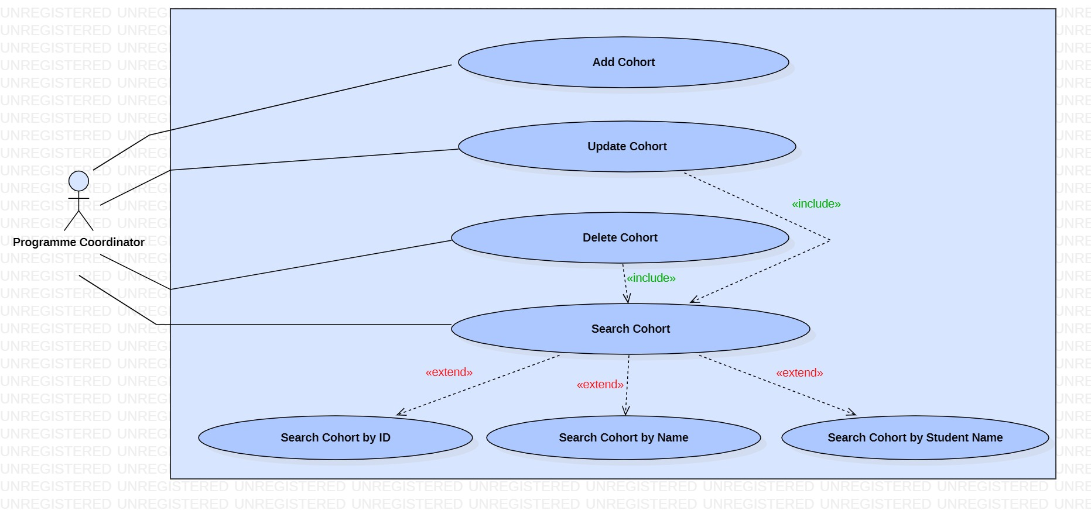

|  |  |
| --- | --- |
| **Use case name:** Add Cohort | |
| **Participating actors(s):** Programme Coordinator | |
| **Preconditions:** Before the use case starts, actor must log in the system | |
| **Flow of events** | |
| **Actor Action** | **System Response** |
| 1. Enter the cohort’s details  3. Actor confirms the details and save | 2. Validates if data have been typed in the correct format and allow actor to confirm the details.  4. Displays a confirming message that module has been added. |
| **Postconditions:** Cohorthas been added successfully | |
| **Special Requirements:** None | |

|  |  |
| --- | --- |
| **Use case name:** Update Cohort | |
| **Participating actors(s):** Programme Coordinator | |
| **Preconditions:** Before the use case starts, actor must log in the system and must search for the cohort first and then proceed the update. | |
| **Flow of events** | |
| **Actor Action** | **System Response** |
| 1. Enter the cohort’s details  3. Allow the actor to update the required data and save. | 2. Retrieves and displays the cohort’s details  4. Displays a confirming message that cohort has been updated. |
| **Postconditions:** Cohort has been updated successfully | |
| **Special Requirements:** None | |

|  |  |
| --- | --- |
| **Use case name:** Delete Cohort | |
| **Participating actors(s):** Programme Coordinator | |
| **Preconditions:** Before the use case starts, the actor must log in the system and then search for the module before proceeding with the deletion | |
| **Flow of events** | |
| **Actor Action** | **System Response** |
| 1. Enter cohort’s details.  3. Selects delete. | 2. Retrieves the data, display cohort’s details and allow actor to delete.  4. Displays a confirming delete verification dialog. |
| **Postconditions:** Cohort has been deleted successfully | |
| **Special Requirements:** none | |

|  |  |
| --- | --- |
| **Use case name:** Search Cohort | |
| **Participating actors(s):** Programme Coordinator | |
| **Preconditions:** Before the use case starts, actors must log in the system. | |
| **Flow of events** | |
| **Actor Action** | **System Response** |
| 1. Enter cohort’s name/ID/ Students’ name  3. The use case ends when the actors find the cohort | 2. Retrieves and displays the data if it exists. |
| **Postconditions:**  The actors successfully find the cohort they are looking for. | |
| **Special Requirements:** Actors can eithersearch the cohort by its name, ID or students’ names at a time. | |

### **5.2.5 Lecturer**

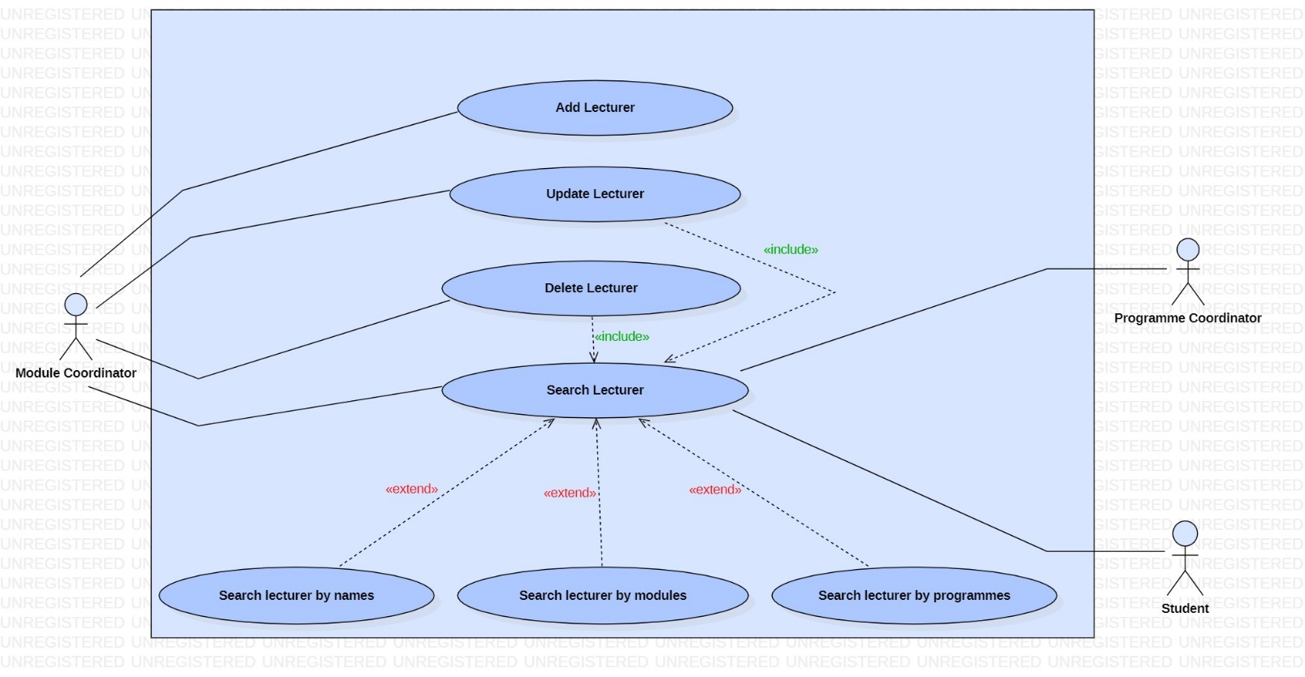

|  |  |
| --- | --- |
| **Use case name:** Add Lecturer | |
| **Participating actors(s):** Module Coordinator | |
| **Preconditions:** Before the use case starts, actor must log in the system | |
| **Flow of events** | |
| **Actor Action** | **System Response** |
| 1. Enter the lecturer’s details  3. Actor confirms the details and save | 2. Validates if data have been typed in the correct format and allow actor to confirm the details.  4. Displays a confirming message that lecturer has been added. |
| **Postconditions:** Lecturerhas been added successfully | |
| **Special Requirements:** None | |

|  |  |
| --- | --- |
| **Use case name:** Update Lecturer | |
| **Participating actors(s):** Module Coordinator | |
| **Preconditions:** Before the use case starts, actor must log in the system and must search for the lecturer first and then proceed with the update. | |
| **Flow of events** | |
| **Actor Action** | **System Response** |
| 1. Enter the lecturer’s details  3. Allow the actor to update the required data and save. | 2. Retrieves and displays the cohort’s details  4. Displays a confirming message that lecturer has been updated. |
| **Postconditions:** Lecturer has been updated successfully | |
| **Special Requirements:** None | |

|  |  |
| --- | --- |
| **Use case name:** Delete Lecturer | |
| **Participating actors(s):** Module Coordinator | |
| **Preconditions:** Before the use case starts, the actor must log in the system and then search for the lecturer before proceeding with the deletion | |
| **Flow of events** | |
| **Actor Action** | **System Response** |
| 1. Enter lecturer’s details.  3. Selects delete. | 2. Retrieves the data, display lecturer’s details and allow actor to delete.  4. Displays a confirming delete verification dialog. |
| **Postconditions:** Lecturer has been deleted successfully | |
| **Special Requirements:** none | |

|  |  |
| --- | --- |
| **Use case name:** Search Lecturer | |
| **Participating actors(s):** Module Coordinator, Programme Coordinator, Student | |
| **Preconditions:** Before the use case starts, actors must log in the system. | |
| **Flow of events** | |
| **Actor Action** | **System Response** |
| 1. Enter lecturer’s name/ module/ programmes  3. The use case ends when the actors find the lecturer | 2. Retrieves and displays the data if it exists. |
| **Postconditions:**  The actors successfully find the lecturer they are looking for. | |
| **Special Requirements:** Actors can eithersearch the lecturer by his name/module or programme at a time. | |

### **5.2.6 Coursework**

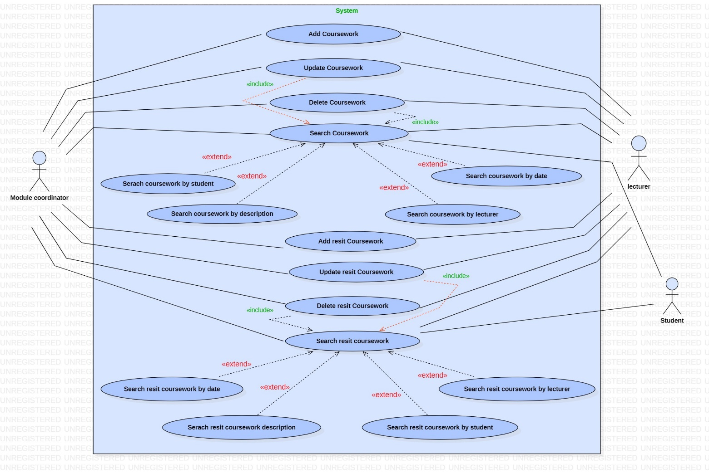

|  |  |
| --- | --- |
| **Use case name:** Add Coursework | |
| **Participating actors(s):** Module Coordinator, lecturer | |
| **Preconditions:** Before the use case starts, actors must log in the system | |
| **Flow of events** | |
| **Actor Action** | **System Response** |
| 1. Enter the coursework’s details  3. Actors confirm the details and save | 2. Validates if data have been typed in the correct format and allows actor to confirm the details.  4. Displays a confirming message that coursework has been added. |
| **Postconditions:** Courseworkhas been added successfully | |
| **Special Requirements:** None | |

|  |  |
| --- | --- |
| **Use case name:** Update Coursework | |
| **Participating actors(s):** Module Coordinator, Lecturer | |
| **Preconditions:** Before the use case starts, actors must log in the system and must search for the coursework first and then proceed with the update. | |
| **Flow of events** | |
| **Actor Action** | **System Response** |
| 1. Enter the coursework’s details  3. Allow the actors to update the required data and save. | 2. Retrieves and displays the coursework’s details  4. Displays a confirming message that lecturer has been updated. |
| **Postconditions:** Coursework has been updated successfully | |
| **Special Requirements:** None | |

|  |  |
| --- | --- |
| **Use case name:** Delete Coursework | |
| **Participating actors(s):** Module Coordinator, Lecturer | |
| **Preconditions:** Before the use case starts, the actors must log in the system and then search for the coursework before proceeding with the deletion | |
| **Flow of events** | |
| **Actor Action** | **System Response** |
| 1. Enter coursework’s details.  3. Selects delete. | 2. Retrieves the data, display coursework’s details and allow actor to delete.  4. Displays a confirming delete verification dialog. |
| **Postconditions:** Coursework has been deleted successfully | |
| **Special Requirements:** none | |

|  |  |
| --- | --- |
| **Use case name:** Search Coursework | |
| **Participating actors(s):** Module Coordinator, Lecturer | |
| **Preconditions:** Before the use case starts, actors must log in the system. | |
| **Flow of events** | |
| **Actor Action** | **System Response** |
| 1. Enter coursework’s details  3. The use case ends when the actors find the coursework | 2. Retrieves and displays the data if it exists. |
| **Postconditions:**  The actors successfully find the coursework they are looking for. | |
| **Special Requirements:** Actors can eithersearch coursework by student/description/ lecturer/date at a time. | |

|  |  |
| --- | --- |
| **Use case name:** Add Re-sit Coursework | |
| **Participating actors(s):** Module Coordinator, lecturer | |
| **Preconditions:** Before the use case starts, actors must log in the system | |
| **Flow of events** | |
| **Actor Action** | **System Response** |
| 1. Enter the re-sit coursework’s details  3. Actors confirm the details and save | 2. Validates if data have been typed in the correct format and allows actor to confirm the details.  4. Displays a confirming message that re-sit coursework has been added. |
| **Postconditions:** Resitcourseworkhas been added successfully | |
| **Special Requirements:** None | |

|  |  |
| --- | --- |
| **Use case name:** Update re-sit coursework | |
| **Participating actors(s):** Module Coordinator, Lecturer | |
| **Preconditions:** Before the use case starts, the actor must log in the system and then search for the re-sit before proceeding with the update. | |
| **Flow of events** | |
| **Actor Action** | **System Response** |
| 1. Enter the re-sit coursework’s details  3. Allow the actors to update the required data and save. | 2. Retrieves and displays the re-sit coursework’s details  4. Displays a confirming message that the re-sit coursework has been updated. |
| **Postconditions:** Resit coursework has been updated successfully | |
| **Special Requirements:** None | |

|  |  |
| --- | --- |
| **Use case name:** Delete Resit coursework | |
| **Participating actors(s):** Module Coordinator, Lecturer | |
| **Preconditions:** Before the use case starts, the actor must log in the system and then search for the re-sit coursework before proceeding with the deletion | |
| **Flow of events** | |
| **Actor Action** | **System Response** |
| 1. Enter re-sit coursework’s details.  3. Selects delete. | 2. Retrieves the data, display the re-sit coursework’s details, and allow actor to delete.  4. Displays a confirming delete verification dialog. |
| **Postconditions:** Resit coursework has been deleted successfully | |
| **Special Requirements:** none | |

|  |  |
| --- | --- |
| **Use case name:** Search re-sit coursework | |
| **Participating actors(s):** Module Coordinator, Lecturer | |
| **Preconditions:** Before the use case starts, actors must log in the system. | |
| **Flow of events** | |
| **Actor Action** | **System Response** |
| 1. Enter coursework’s details  3. The use case ends when the actors find the re-sit coursework | 2. Retrieves and displays the data if it exists. |
| **Postconditions:**  The actors successfully find the coursework they are looking for. | |
| **Special Requirements:** Actors can eithersearch re-sit coursework by date/description/student/lecturer at a time. | |

### **5.2.7 Exam**

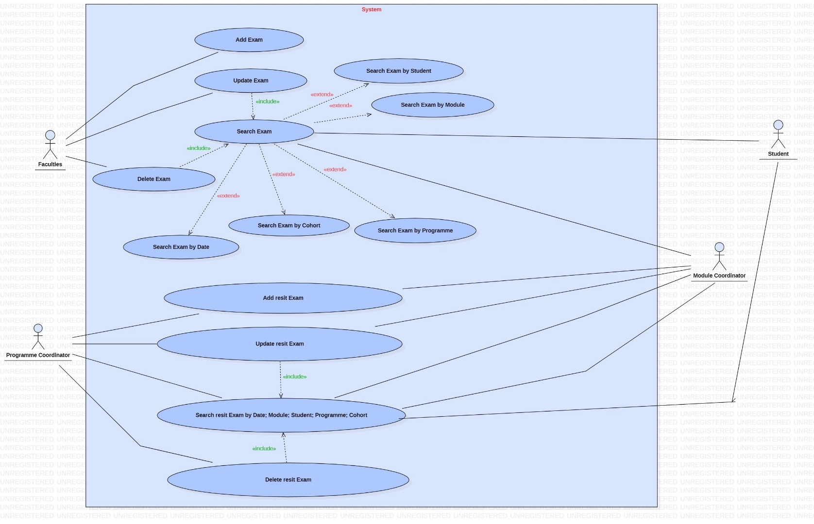

|  |  |
| --- | --- |
| **Use case name:** Add Exam | |
| **Participating actors(s):** Faculties | |
| **Preconditions:** Before the use case starts, actors must log in the system | |
| **Flow of events** | |
| **Actor Action** | **System Response** |
| 1. Enter the exam’s details  3. Actors confirm the details and save | 2. Validates if data have been typed in the correct format and allows actor to confirm the details.  4. Displays a confirming message that exam has been added. |
| **Postconditions:** Examhas been added successfully | |
| **Special Requirements:** None | |

|  |  |
| --- | --- |
| **Use case name:** Update Exam | |
| **Participating actors(s):** Faculties | |
| **Preconditions:** Before the use case starts, actors must log in the system and must search for the exam first and then proceed with the update. | |
| **Flow of events** | |
| **Actor Action** | **System Response** |
| 1. Enter the exam’s details  3. Allow the actors to update the required data and save. | 2. Retrieves and displays the exam’s details  4. Displays a confirming message that lecturer has been updated. |
| **Postconditions:** Exam has been updated successfully | |
| **Special Requirements:** None | |

|  |  |
| --- | --- |
| **Use case name:** Delete Exam | |
| **Participating actors(s):** Faculties | |
| **Preconditions:** Before the use case starts, the actors must log in the system and then search for the exam before proceeding with the deletion | |
| **Flow of events** | |
| **Actor Action** | **System Response** |
| 1. Enter exam’s details.  3. Selects delete. | 2. Retrieves the data, exam’s details and allow actor to delete.  4. Displays a confirming delete verification dialog. |
| **Postconditions:** Exam has been deleted successfully | |
| **Special Requirements:** none | |

|  |  |
| --- | --- |
| **Use case name:** Search Exam | |
| **Participating actors(s):** Module Coordinator, Student | |
| **Preconditions:** Before the use case starts, actors must log in the system. | |
| **Flow of events** | |
| **Actor Action** | **System Response** |
| 1. Enter exam’s details  3. The use case ends when the actors find the exam | 2. Retrieves and displays the data if it exists. |
| **Postconditions:**  The actors successfully find the exam they are looking for. | |
| **Special Requirements:** Actors can either  Search Exam by date, module, student, programme, cohort at a time | |

|  |  |
| --- | --- |
| **Use case name:** Add Re-sit Exam | |
| **Participating actors(s):** Module Coordinator, Programme Coordinator | |
| **Preconditions:** Before the use case starts, actors must log in the system | |
| **Flow of events** | |
| **Actor Action** | **System Response** |
| 1. Enter the re-sit exam’s details  3. Actors confirm the details and save | 2. Validates if data have been typed in the correct format and allows actor to confirm the details.  4. Displays a confirming message that re-sit exam has been added. |
| **Postconditions:** Re-sitexam has been added successfully | |
| **Special Requirements:** None | |

|  |  |
| --- | --- |
| **Use case name:** Update re-sit Exam | |
| **Participating actors(s):** Module Coordinator, Programme Coordinator | |
| **Preconditions:** Before the use case starts, actors must log in the system and must search for the re-sit exam first and then proceed with the update. | |
| **Flow of events** | |
| **Actor Action** | **System Response** |
| 1. Enter the re-sit exam’s details  3. Allow the actors to update the required data and save. | 2. Retrieves and displays the re-sit exam’s details  4. Displays a confirming message that the re-sit exam has been updated. |
| **Postconditions:** Re-sit exam has been updated successfully | |
| **Special Requirements:** None | |

|  |  |
| --- | --- |
| **Use case name:** Delete Resit Exam | |
| **Participating actors(s):** Module Coordinator, Programme Coordinator | |
| **Preconditions:** Before the use case starts, the actor must log in the system and then search for the re-sit exam before proceeding with the deletion | |
| **Flow of events** | |
| **Actor Action** | **System Response** |
| 1. Enter re-sit exam s details.  3. Selects delete. | 2. Retrieves the data, display the re-sit exam’s details, and allow actor to delete.  4. Displays a confirming delete verification dialog. |
| **Postconditions:** Resit exam has been deleted successfully | |
| **Special Requirements:** none | |

|  |  |
| --- | --- |
| **Use case name:** Search re-sit Exam | |
| **Participating actors(s):** Module Coordinator, Programme Coordinator, Student | |
| **Preconditions:** Before the use case starts, actors must log in the system. | |
| **Flow of events** | |
| **Actor Action** | **System Response** |
| 1. Enter exam’s details  3. The use case ends when the actors find the re-sit exam | 2. Retrieves and displays the data if it exists. |
| **Postconditions:**  The actors successfully find the exam they are looking for. | |
| **Special Requirements:** Actors can eithersearch re-sit exam by date, module, student, programme, cohort at a time. | |

### **5.2.8 Work Placement**

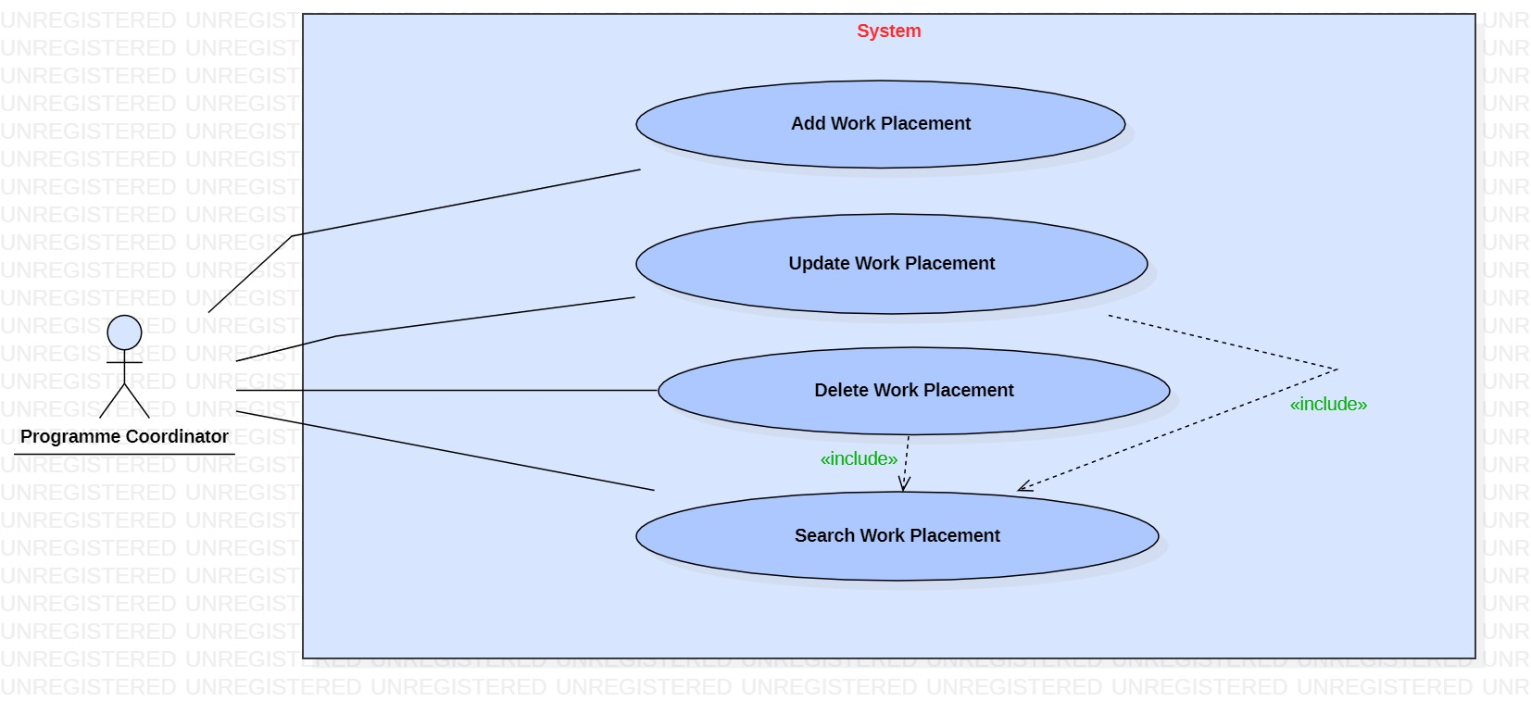

|  |  |
| --- | --- |
| **Use case name:** Add Work placement | |
| **Participating actors(s):** Programme Coordinator | |
| **Preconditions:** Before the use case starts, actor must log in the system | |
| **Flow of events** | |
| **Actor Action** | **System Response** |
| 1. Enter the work placement’s details  3. Actor confirms the details and save | 2. Validates if data have been typed in the correct format and allow actor to confirm the details.  4. Displays a confirming message that work placement has been added. |
| **Postconditions:** Work placementhas been added successfully | |
| **Special Requirements:** None | |

|  |  |
| --- | --- |
| **Use case name:** Update Work placement | |
| **Participating actors(s):** Programme Coordinator | |
| **Preconditions:** Before the use case starts, actor must log in the system and must search for the work placement first and then proceed with the update. | |
| **Flow of events** | |
| **Actor Action** | **System Response** |
| 1. Enter the work placement’s details  3. Allow the actor to update the required data and save. | 2. Retrieves and displays the cohort’s details  4. Displays a confirming message that work placement has been updated. |
| **Postconditions:** Work placement has been updated successfully | |
| **Special Requirements:** None | |

|  |  |
| --- | --- |
| **Use case name:** Delete Work placement | |
| **Participating actors(s):** Programme Coordinator | |
| **Preconditions:** Before the use case starts, the actor must log in the system and then search for the work placement before proceeding with the deletion | |
| **Flow of events** | |
| **Actor Action** | **System Response** |
| 1. Enter work placement’s details.  3. Selects delete. | 2. Retrieves the data, display work placement’s details and allow actor to delete.  4. Displays a confirming delete verification dialog. |
| **Postconditions:** Work placement has been deleted successfully | |
| **Special Requirements:** none | |

|  |  |
| --- | --- |
| **Use case name:** Search Work placement | |
| **Participating actors(s):** Programme Coordinator | |
| **Preconditions:** Before the use case starts, actors must log in the system. | |
| **Flow of events** | |
| **Actor Action** | **System Response** |
| 1. Enter work placement  3. The use case ends when the actors find the work placement | 2. Retrieves and displays the data if it exists. |
| **Postconditions:**  The actors successfully find the work placement they are looking for. | |
| **Special Requirements:** None | |

### **5.2.9 Project**

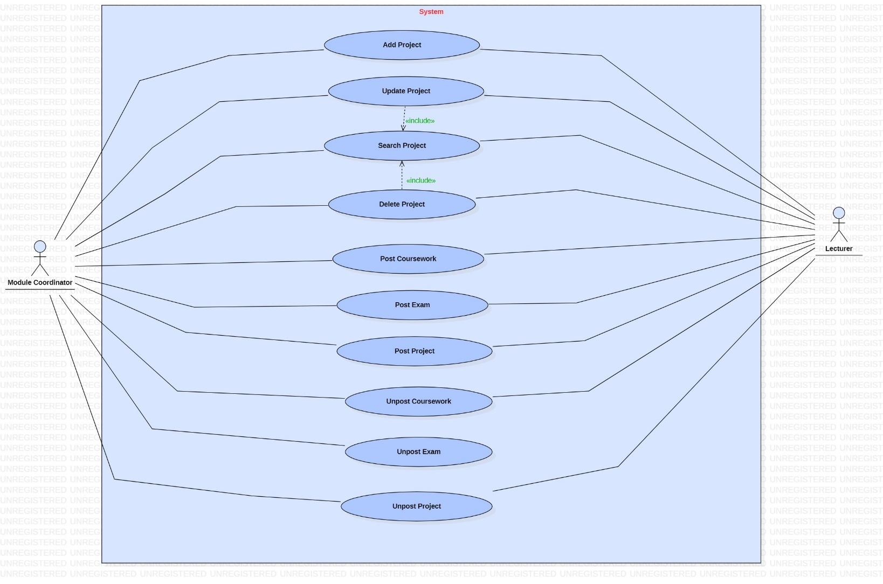

|  |  |
| --- | --- |
| **Use case name:** Add Project | |
| **Participating actors(s):** Module Coordinator, Lecturer | |
| **Preconditions:** Before the use case starts, actor must log in the system | |
| **Flow of events** | |
| **Actor Action** | **System Response** |
| 1. Enter the project’s details  3. Actor confirms the details and save | 2. Validates if data have been typed in the correct format and allow actor to confirm the details.  4. Displays a confirming message that project has been added. |
| **Postconditions:** Project has been added successfully | |
| **Special Requirements:** None | |

|  |  |
| --- | --- |
| **Use case name:** Update Project | |
| **Participating actors(s):** Module Coordinator, Lecturer | |
| **Preconditions:** Before the use case starts, actor must log in the system and must search for the project first and then proceed with the update. | |
| **Flow of events** | |
| **Actor Action** | **System Response** |
| 1. Enter the project’s details  3. Allow the actor to update the required data and save. | 2. Retrieves and displays the project’s details  4. Displays a confirming message that project has been updated. |
| **Postconditions:** Project has been updated successfully | |
| **Special Requirements:** None | |

|  |  |
| --- | --- |
| **Use case name:** Delete Project | |
| **Participating actors(s):** Module Coordinator, Lecturer | |
| **Preconditions:** Before the use case starts, the actor must log in the system and then search for the project before proceeding with the deletion | |
| **Flow of events** | |
| **Actor Action** | **System Response** |
| 1. Enter project’s details.  3. Selects delete. | 2. Retrieves the data, display project s details and allow actor to delete.  4. Displays a confirming delete verification dialog. |
| **Postconditions:** Project has been deleted successfully | |
| **Special Requirements:** none | |

|  |  |
| --- | --- |
| **Use case name:** Search Project | |
| **Participating actors(s):** Module Coordinator, Lecturer | |
| **Preconditions:** Before the use case starts, actors must log in the system. | |
| **Flow of events** | |
| **Actor Action** | **System Response** |
| 1. Enter project’s details  3. The use case ends when the actors find the project | 2. Retrieves and displays the data if it exists. |
| **Postconditions:**  The actors successfully find the project they are looking for. | |
| **Special Requirements:** None | |

|  |  |
| --- | --- |
| **Use case name:** Post coursework | |
| **Participating actors(s):** Module Coordinator, Lecturer | |
| **Preconditions:** Before the use case starts, actors must log in the system. | |
| **Flow of events** | |
| **Actor Action** | **System Response** |
| 1. Enter coursework’s details  3. Actors confirm the details and save | 2. Dialog pops up to confirm the posting of the coursework  4. Displays a confirming message that coursework has been posted. |
| **Postconditions:**  The actors successfully post the coursework | |
| **Special Requirements:** None | |

|  |  |
| --- | --- |
| **Use case name:** Post exam | |
| **Participating actors(s):** Module Coordinator, Lecturer | |
| **Preconditions:** Before the use case starts, actors must log in the system. | |
| **Flow of events** | |
| **Actor Action** | **System Response** |
| 1. Input exam’s details  3. Actors confirm the details and save. | 2. Pop of a dialog box to confirm the posting of the exam  4. Displays a confirming message that exam has been posted. |
| **Postconditions:**  The actors successfully post the exam | |
| **Special Requirements:** None | |

|  |  |
| --- | --- |
| **Use case name:** Post project | |
| **Participating actors(s):** Module Coordinator, Lecturer | |
| **Preconditions:** Before the use case starts, actors must log in the system. | |
| **Flow of events** | |
| **Actor Action** | **System Response** |
| 1. Input project’s details  3. Actors confirm the details and save | 2. Pop up of the dialog box to confirm the posting of the project  4. Displays a confirming message that project has been posted. |
| **Postconditions:**  The actors successfully post the project | |
| **Special Requirements:** None | |

|  |  |
| --- | --- |
| **Use case name:** Un-post coursework | |
| **Participating actors(s):** Module Coordinator, Lecturer | |
| **Preconditions:** Before the use case starts, actors must log in the system. | |
| **Flow of events** | |
| **Actor Action** | **System Response** |
| 1. Enter coursework details  3. Actor confirm the details | 2. Retrieves and displays the data if it exists and shows a dialog box to confirm the un-posting of the coursework  4. Displays a message that coursework has been un-posted. |
| **Postconditions:**  The actors successfully un-post the coursework | |
| **Special Requirements:** None | |

|  |  |
| --- | --- |
| **Use case name:** Un-post exam | |
| **Participating actors(s):** Module Coordinator | |
| **Preconditions:** Before the use case starts, actors must log in the system. | |
| **Flow of events** | |
| **Actor Action** | **System Response** |
| 1. Enter exam’s details  3. Actor confirm the details | 2. Retrieves and displays the data if it exists and shows a dialog box to confirm the un-posting of the exam  4. Displays a message that exam has been un-posted. |
| **Postconditions:**  The actors successfully un-post the exam | |
| **Special Requirements:** None | |

|  |  |
| --- | --- |
| **Use case name:** Un-post project | |
| **Participating actors(s):** Module Coordinator, Lecturer | |
| **Preconditions:** Before the use case starts, actors must log in the system. | |
| **Flow of events** | |
| **Actor Action** | **System Response** |
| 1. Enter project’s details  3. Actor confirm the details | 2. Retrieves and displays the data if it exists and shows a dialog box to confirm the un-posting of the project  4. Displays a message that project has been un-posted. |
| **Postconditions:**  The actors successfully un-post the project | |
| **Special Requirements:** None | |

### **5.2.10 Moderation**

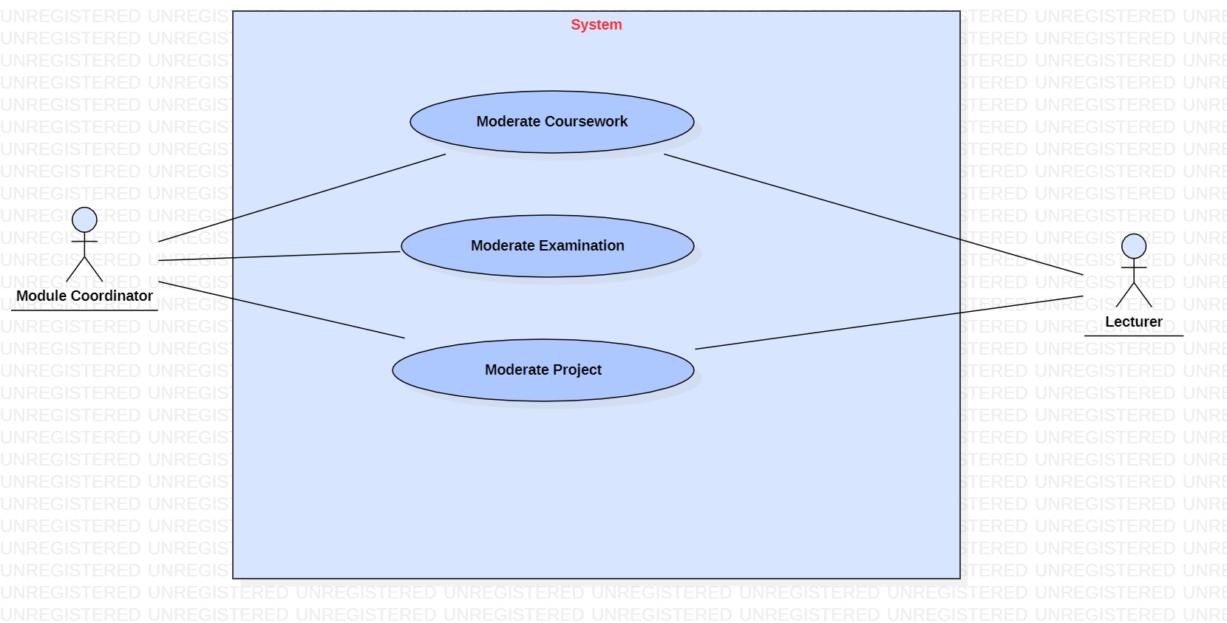

|  |  |
| --- | --- |
| **Use case name:** Moderate Coursework | |
| **Participating actors(s):** Module Coordinator, Lecturer | |
| **Preconditions:** Before the use case starts, actor must log in the system | |
| **Flow of events** | |
| **Actor Action** | **System Response** |
| 1. Enter details to moderate coursework  3. Actor confirms the details and save | 2. Validates if data have been typed in the correct format and allow actor to confirm the details.  4. Displays a confirming message that coursework has been moderated. |
| **Postconditions:** Courseworkhas been moderated successfully | |
| **Special Requirements:** Retrieve coursework details to moderate | |

|  |  |
| --- | --- |
| **Use case name:** Moderate Examination | |
| **Participating actors(s):** Module Coordinator | |
| **Preconditions:** Before the use case starts, actor must log in the system | |
| **Flow of events** | |
| **Actor Action** | **System Response** |
| 1. Enter details to moderate examination  3. Actor confirms the details and save | 2. Validates if data have been typed in the correct format and allow actor to confirm the details.  4. Displays a confirming message that examination has been moderated. |
| **Postconditions:** Examination has been moderated successfully | |
| **Special Requirements:** Retrieve exam details to moderate | |

|  |  |
| --- | --- |
| **Use case name:** Moderate Project | |
| **Participating actors(s):** Module Coordinator, Lecturer | |
| **Preconditions:** Before the use case starts, actor must log in the system | |
| **Flow of events** | |
| **Actor Action** | **System Response** |
| 1. Enter details to moderate project  3. Actor confirms the details and save | 2. Validates if data have been typed in the correct format and allow actor to confirm the details.  4. Displays a confirming message that project has been moderated. |
| **Postconditions:** Project has been moderated successfully | |
| **Special Requirements:** Retrieve project details to moderate | |

### **5.2.11 Board of Examiners**

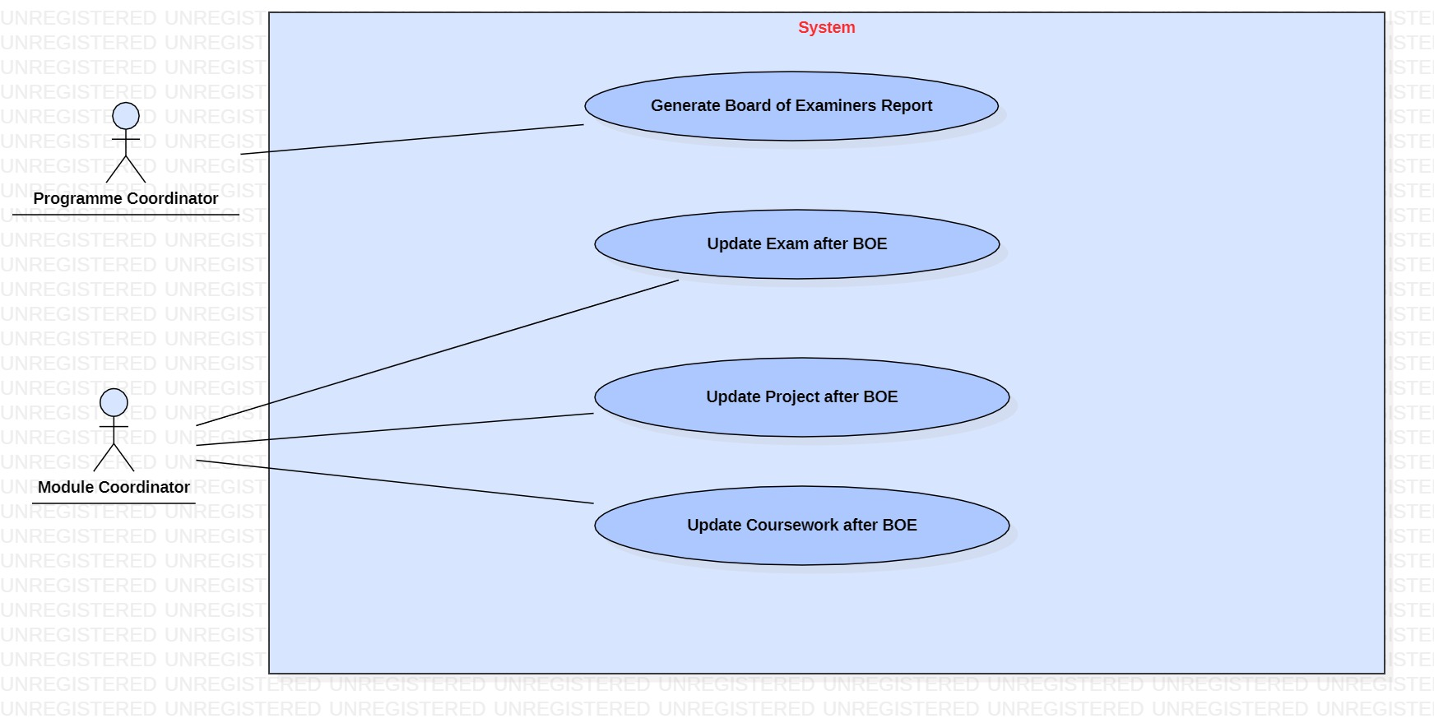

|  |  |
| --- | --- |
| **Use case name:** Generate Board of Examiners report | |
| **Participating actors(s):** Programme Coordinator | |
| **Preconditions:** Before the use case starts, actor must log in the system | |
| **Flow of events** | |
| **Actor Action** | **System Response** |
| 1. Enter the details of Board of Examiners report  3. Actor confirms the details and save | 2. Validates if data have been typed in the correct format and allow actor to confirm the details.  4. Displays a confirming message that report of Board of Examiners has been generated |
| **Postconditions:** Board of Examiners has been generated successfully | |
| **Special Requirements:** None | |

|  |  |
| --- | --- |
| **Use case name:** Update Exam after BOE | |
| **Participating actors(s):** Module Coordinator | |
| **Preconditions:** Before the use case starts, actor must log in the system and must search for the exam first and then proceed with the update. | |
| **Flow of events** | |
| **Actor Action** | **System Response** |
| 1. Enter the exam’s details as per BOE  3. Allow the actor to update the required data and save. | 2. Retrieves and displays the exam’s details as per BOE  4. Displays a confirming message that exam has been updated. |
| **Postconditions:** Exam after BOE has been updated successfully | |
| **Special Requirements:** None | |

|  |  |
| --- | --- |
| **Use case name:** Update Project after BOE | |
| **Participating actors(s):** Module Coordinator | |
| **Preconditions:** Before the use case starts, actor must log in the system and must search for the project first and then proceed with the update. | |
| **Flow of events** | |
| **Actor Action** | **System Response** |
| 1. Enter the project’s details as per BOE  3. Allow the actor to update the required data and save. | 2. Retrieves and displays the project’s details as per BOE  4. Displays a confirming message that project has been updated. |
| **Postconditions:** Project after BOE has been updated successfully | |
| **Special Requirements:** None | |

|  |  |
| --- | --- |
| **Use case name:** Update Coursework after BOE | |
| **Participating actors(s):** Module Coordinator | |
| **Preconditions:** Before the use case starts, actor must log in the system and must search for the exam first and then proceed with the update. | |
| **Flow of events** | |
| **Actor Action** | **System Response** |
| 1. Enter the coursework’s details as per BOE  3. Allow the actor to update the required data and save. | 2. Retrieves and displays the coursework’s details as per BOE  4. Displays a confirming message that coursework has been updated. |
| **Postconditions:** Coursework after BOE has been updated successfully | |
| **Special Requirements:** None | |

### **5.2.12 Generate**

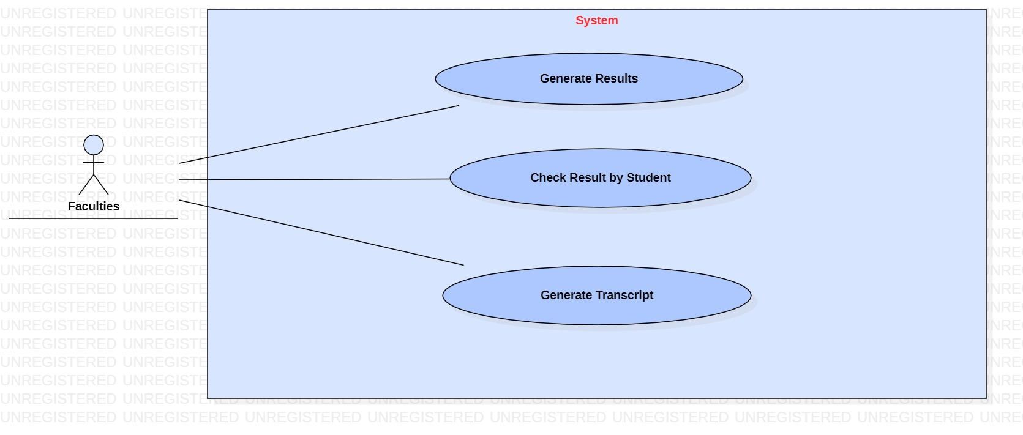

|  |  |
| --- | --- |
| **Use case name:** Generate results | |
| **Participating actors(s):** Faculties | |
| **Preconditions:** Before the use case starts, actor must log in the system | |
| **Flow of events** | |
| **Actor Action** | **System Response** |
| 1. Enter the results of students  3. Actor confirms the details and save | 2. Validates if data have been typed in the correct format and allow actor to confirm the details.  4. Displays a confirming message that results has been generated |
| **Postconditions:** Results has been generated successfully | |
| **Special Requirements:** None | |

|  |  |
| --- | --- |
| **Use case name:** Check results by students | |
| **Participating actors(s):** Faculties | |
| **Preconditions:** Before the use case starts, actor must log in the system | |
| **Flow of events** | |
| **Actor Action** | **System Response** |
| 1. Enter student’s details  3. The use case ends when the actors find the results of students. | 2. Retrieves and displays the data if it exists. |
| **Postconditions:** The actors successfully find the results they are looking for. | |
| **Special Requirements:** Actors can search the results by student’s details at a time | |

|  |  |
| --- | --- |
| **Use case name:** Generate Transcript | |
| **Participating actors(s):** Faculties | |
| **Preconditions:** Before the use case starts, actor must log in the system | |
| **Flow of events** | |
| **Actor Action** | **System Response** |
| 1. Enter the transcript’s details  3. Actor confirms the details and save | 2. Validates if data have been typed in the correct format and allow actor to confirm the details.  4. Displays a confirming message that Transcript has been generated |
| **Postconditions:** Transcript has been generated successfully | |
| **Special Requirements:** None | |

### **5.2.13 Attendance**

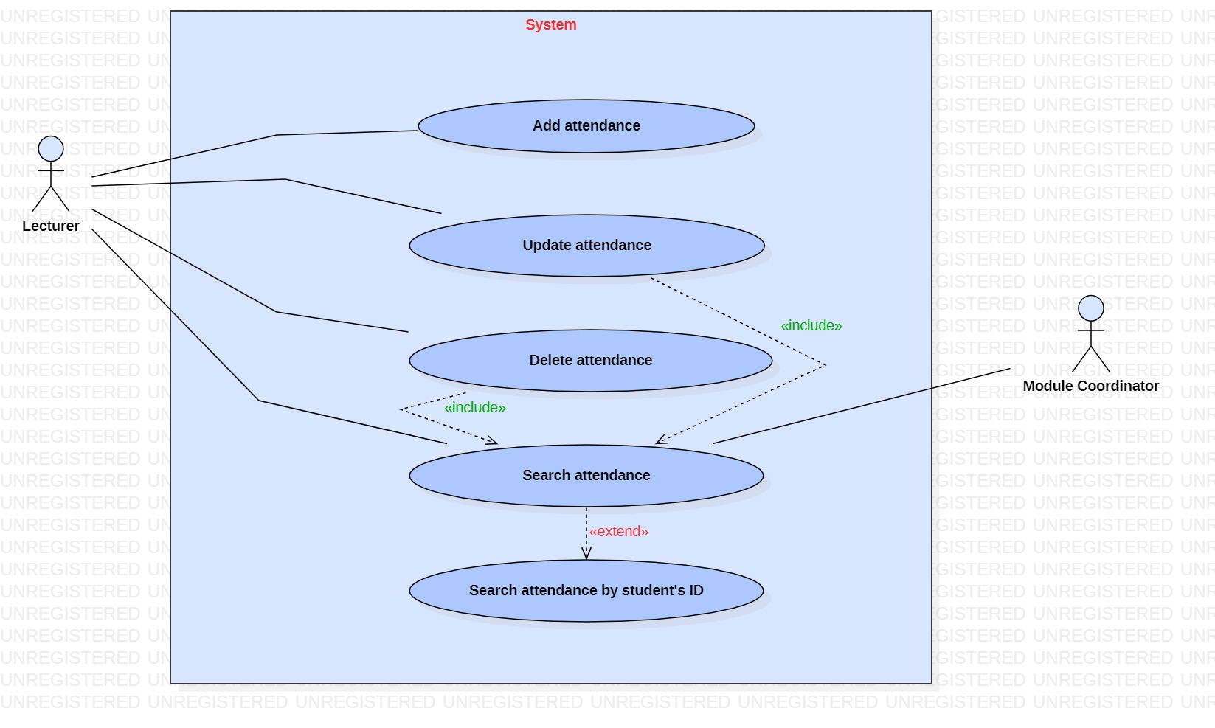

|  |  |
| --- | --- |
| **Use case name:** Add attendance | |
| **Participating actors(s):** Lecturer | |
| **Preconditions:** Before the use case starts, actor must log in the system | |
| **Flow of events** | |
| **Actor Action** | **System Response** |
| 1. Enter the attendance’s details  3. Actor confirms the details and save | 2. Validates if data have been typed in the correct format and allow actor to confirm the details.  4. Displays a confirming message that attendance has been added. |
| **Postconditions:** Attendance has been added successfully | |
| **Special Requirements:** None | |

|  |  |
| --- | --- |
| **Use case name:** Update attendance | |
| **Participating actors(s):**  Lecturer | |
| **Preconditions:** Before the use case starts, actor must log in the system and then search for the attendance before proceeding with the update | |
| **Flow of events** | |
| **Actor Action** | **System Response** |
| 1. Enter the attendance’s details  3. Allow the actor to update the required data and save. | 2. Retrieves and displays the attendance’s details  4. Displays a confirming message that attendance has been updated. |
| **Postconditions:** Attendance has been updated successfully | |
| **Special Requirements:** None | |

|  |  |
| --- | --- |
| **Use case name:** Delete attendance | |
| **Participating actors(s):** Lecturer | |
| **Preconditions:** Before the use case starts, the actor must log in the system and then actor must search for the attendance before proceeding with the deletion | |
| **Flow of events** | |
| **Actor Action** | **System Response** |
| 1. Enter attendance’s details.  3. Selects delete. | 2. Retrieves the data, display attendance’s details and allow actor to delete.  4. Displays a confirming delete verification dialog. |
| **Postconditions:** Attendance has been deleted successfully | |
| **Special Requirements:** None | |

|  |  |
| --- | --- |
| **Use case name:** Search attendance | |
| **Participating actors(s):** Modulecoordinator, lecturer | |
| **Preconditions:** Before the use case starts, actors must log in the system. | |
| **Flow of events** | |
| **Actor Action** | **System Response** |
| 1. Enter students’ ID  3. The use case ends when the actors find the attendance. | 2. Retrieves and displays the data if it exists. |
| **Postconditions:**  The actors successfully find the attendance they are looking for. | |
| **Special Requirements:** Actors cansearch attendance by students’ ID at a time | |

### **5.2.14 Account**

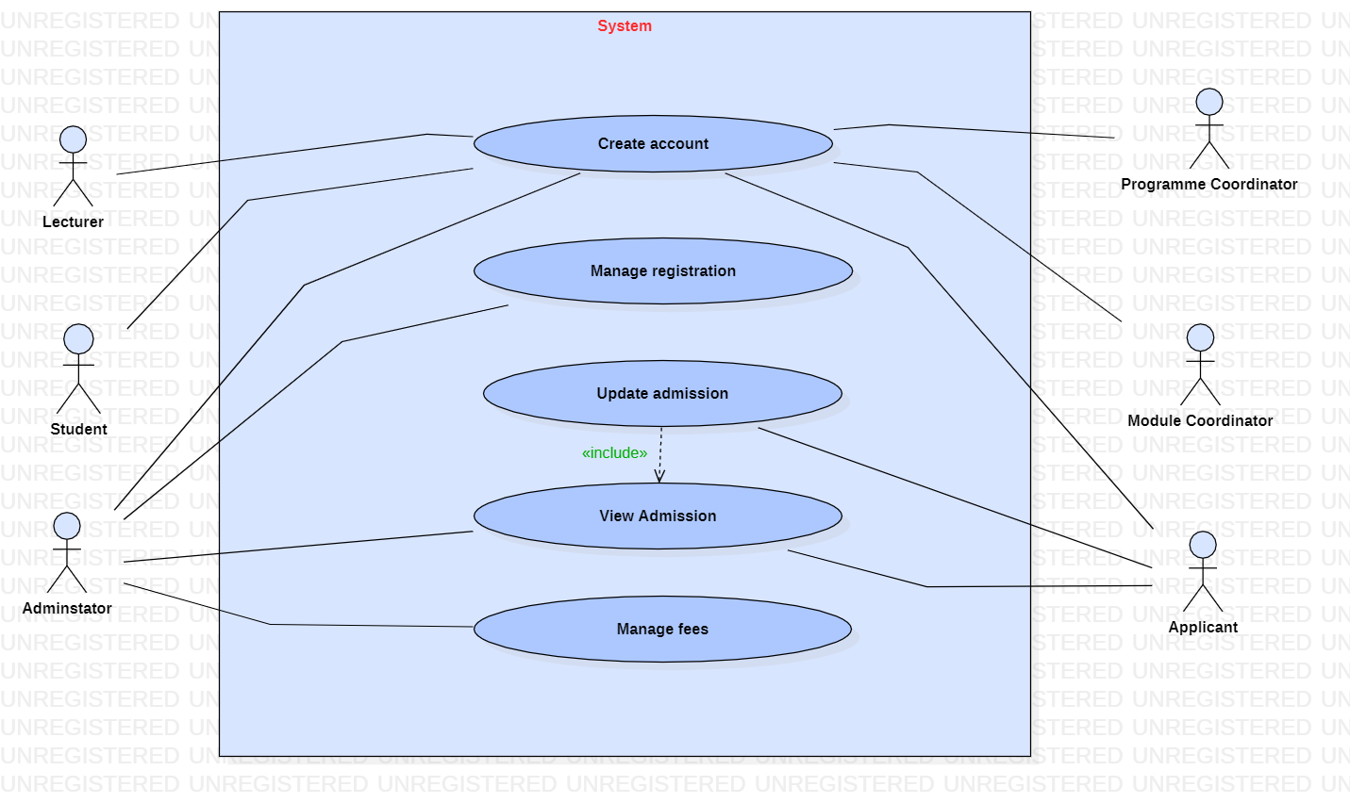

|  |  |
| --- | --- |
| **Use case name:** Create Account | |
| **Participating actors(s):** Lecturer, Student, Administrator, Programme Coordinator, Module Coordinator, Applicant | |
| **Preconditions:** None | |
| **Flow of events** | |
| **Actor Action** | **System Response** |
| 1. Enter the details for creation of the account  3. Actor confirms the details and save | 2. Validates if data have been typed in the correct format and allow actor to confirm the details.  4. Displays a confirming message that account has been created |
| **Postconditions:** Account has been created successfully | |
| **Special Requirements:** None | |

|  |  |
| --- | --- |
| **Use case name:** Manage registration | |
| **Participating actors(s):** Administrator | |
| **Preconditions:** Before the use case starts, actor must log in the system | |
| **Flow of events** | |
| **Actor Action** | **System Response** |
| 1. Enter registration’s details  3. The use case ends when registration has been managed | 2. Retrieves and displays the registration details |
| **Postconditions:** Registration has been managed successfully. | |
| **Special Requirements:** None | |

|  |  |
| --- | --- |
| **Use case name:** Update admission | |
| **Participating actors(s):** Applicant | |
| **Preconditions:** Before the use case starts, actors must log in the system and must view the admission first before proceeding with the update. | |
| **Flow of events** | |
| **Actor Action** | **System Response** |
| 1. Enter admission’s details  3. Allow the actor to update the required data and save. | 2. Retrieves and displays the data if it exists.  4. Displays a confirming message that the admission has been updated |
| **Postconditions:**  The admission has been updated successfully | |
| **Special Requirements:** None | |

|  |  |
| --- | --- |
| **Use case name:** View admission | |
| **Participating actors(s):** Applicant, Administrator | |
| **Preconditions:** Before the use case starts, actors must log in the system and must view the admission first before proceeding with the update. | |
| **Flow of events** | |
| **Actor Action** | **System Response** |
| 1. Enter admission’s details  3. The use case ends when the actor has viewed the admission | 2. Retrieves and displays the data if it exists. |
| **Postconditions:**  None | |
| **Special Requirements:** None | |

### **5.2.15 Admission**

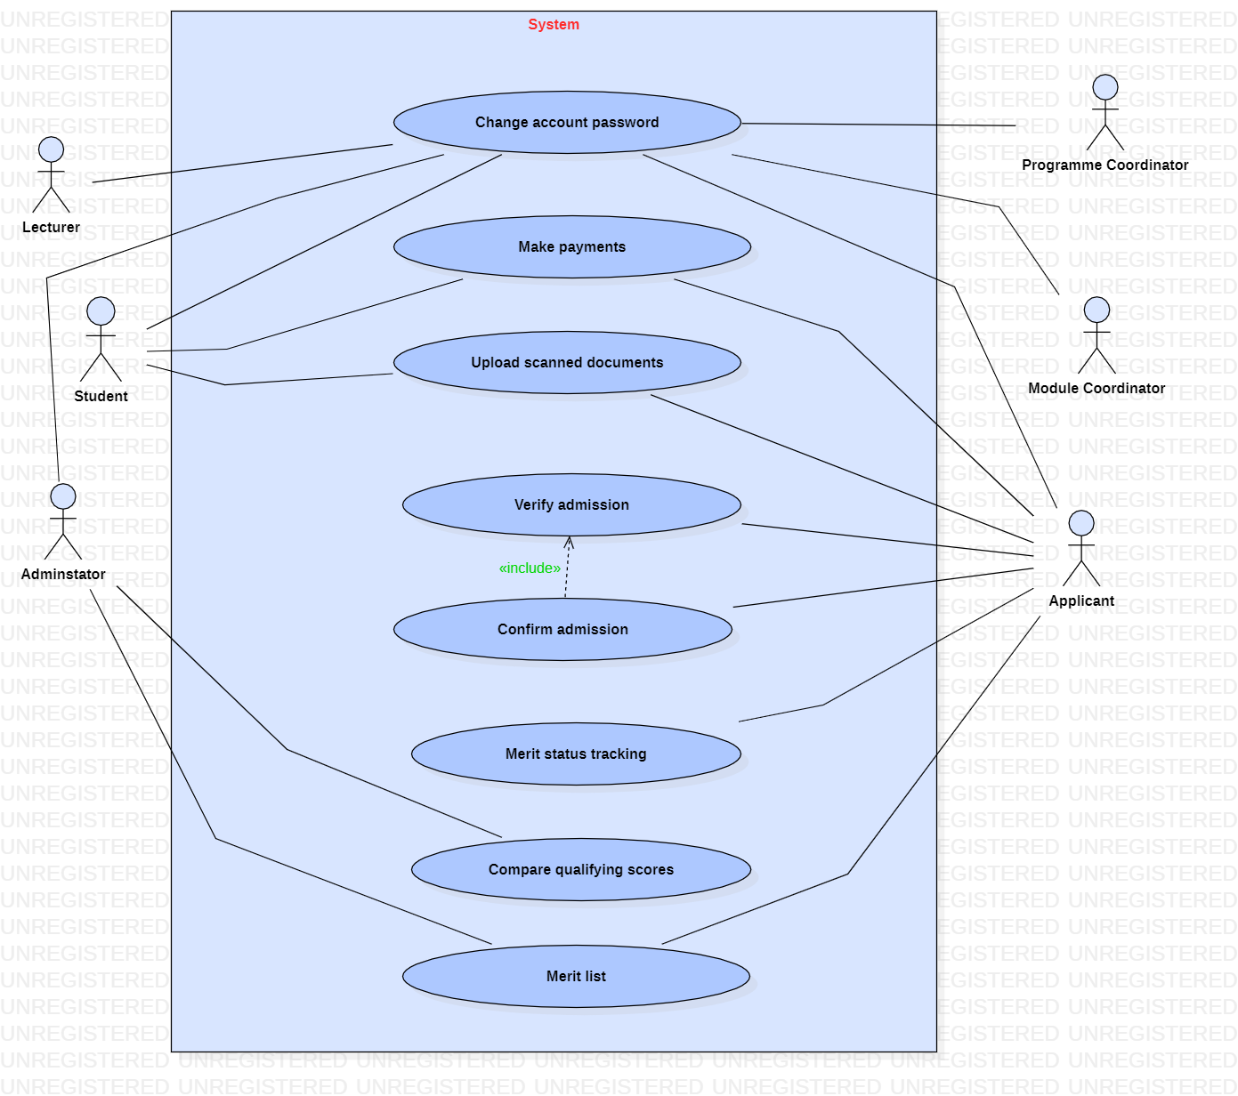

|  |  |
| --- | --- |
| **Use case name:** Manage fees | |
| **Participating actors(s):** Administrator | |
| **Preconditions:** Before the use case starts, actors must log in the system | |
| **Flow of events** | |
| **Actor Action** | **System Response** |
| 1.Enter admission’s details  3. Actor confirms and save | 2.System shows if fees have been received and allow actor to confirm |
| **Postconditions:**  Fees has been managed successfully | |
| **Special Requirements:** None | |
|  | |
| **Use case name:** Change account password | |
| **Participating actors(s):** Lecturer, Student, Administrator, Programme Coordinator, Module Coordinator, Applicant | |
| **Preconditions:** Actors must log in the system first | |
| **Flow of events** | |
| **Actor Action** | **System Response** |
| 1.Sign in and enter account’s details (with current account password)  3. Allow the actor to change the account password and save | 2. Retrieves and display data  4. Displays a confirming message that account’s password has been changed |
| **Postconditions:** Password of the account has been changed successfully | |
| **Special Requirements:** None | |

|  |  |
| --- | --- |
| **Use case name:** Make payments | |
| **Participating actors(s):** Students, Applicants | |
| **Preconditions:** Before the use case starts, actors must log in the system | |
| **Flow of events** | |
| **Actor Action** | **System Response** |
| 1.Enter payment’s details  3. Actor select the mode of payment and confirm the transaction | 2.Display the mode of payment  4. Shows a confirming message that payment has been done |
| **Postconditions:**  Payment of fees has been successfully made | |
| **Special Requirements:** None | |

|  |  |
| --- | --- |
| **Use case name:** Upload scanned documents | |
| **Participating actors(s):** Applicants, students | |
| **Preconditions:** Actors must log in the system first | |
| **Flow of events** | |
| **Actor Action** | **System Response** |
| 1.Select the required scanned document and upload it.  3. Actor confirms and save. | 2. A pop of the dialog box to confirm the uploading of the documents  3. displays a confirming message that documents have been uploaded |
| **Postconditions:** Documents have been uploaded successfully | |
| **Special Requirements:** None | |

|  |  |
| --- | --- |
| **Use case name:** Verify admission | |
| **Participating actors(s):** Applicant | |
| **Preconditions:** Before the use case starts, actors must log in the system | |
| **Flow of events** | |
| **Actor Action** | **System Response** |
| 1. Enter admission’s details  3. The use case ends once actor has verified the admission | 2. Retrieves and displays the data if it exists. |
| **Postconditions:**  None | |
| **Special Requirements:** None | |

|  |  |
| --- | --- |
| **Use case name:** Confirm admission | |
| **Participating actors(s):** Applicant | |
| **Preconditions:** Before the use case starts, actors must log in the system and must verify the admission first before proceeding with the confirmation | |
| **Flow of events** | |
| **Actor Action** | **System Response** |
| 1. Enter admission’s details  3. Actor verifies and the confirm the admission | 2. Retrieves and displays the data if it exists and allow actor to confirm  4. Displays a message that admission has been confirmed |
| **Postconditions:**  The admission has been confirmed successfully | |
| **Special Requirements:** None | |

|  |  |
| --- | --- |
| **Use case name:** Merit status tracking | |
| **Participating actors(s):** Applicants | |
| **Preconditions:** Actor must log in the system first | |
| **Flow of events** | |
| **Actor Action** | **System Response** |
| 1.Enter tracking details  3.Use case ends once actor viewed the status of the tracking | 2. Displays the status of the tracking merit |
| **Postconditions:** None | |
| **Special Requirements:** None | |

|  |  |
| --- | --- |
| **Use case name:** Compare qualifying scores | |
| **Participating actors(s):** Administrator | |
| **Preconditions:** Actor must log in the system first | |
| **Flow of events** | |
| **Actor Action** | **System Response** |
| 1.Enter the admission details  3.Actor then compares the qualifying scores | 2. retrieves and display the admission results. |
| **Postconditions:** None | |
| **Special Requirements:** None | |

|  |  |
| --- | --- |
| **Use case name:** Merit List | |
| **Participating actors(s):** Administrator, Applicant | |
| **Preconditions:** Actors must log in the system first | |
| **Flow of events** | |
| **Actor Action** | **System Response** |
| 1.Enter exam/ admission details.  3.Actors can view the merit list with the high achiever student / applicant at the top. | 2. retrieves and display the admission results. |
| **Postconditions:** None | |
| **Special Requirements:** None | |

## **5.3 Sequence Diagram**

**Sequence Diagram** displays the time sequence of the objects participating in the interaction. This consists of the vertical dimension (time) and horizontal dimension (different objects).

In the diagram below, the applicant is the actor.

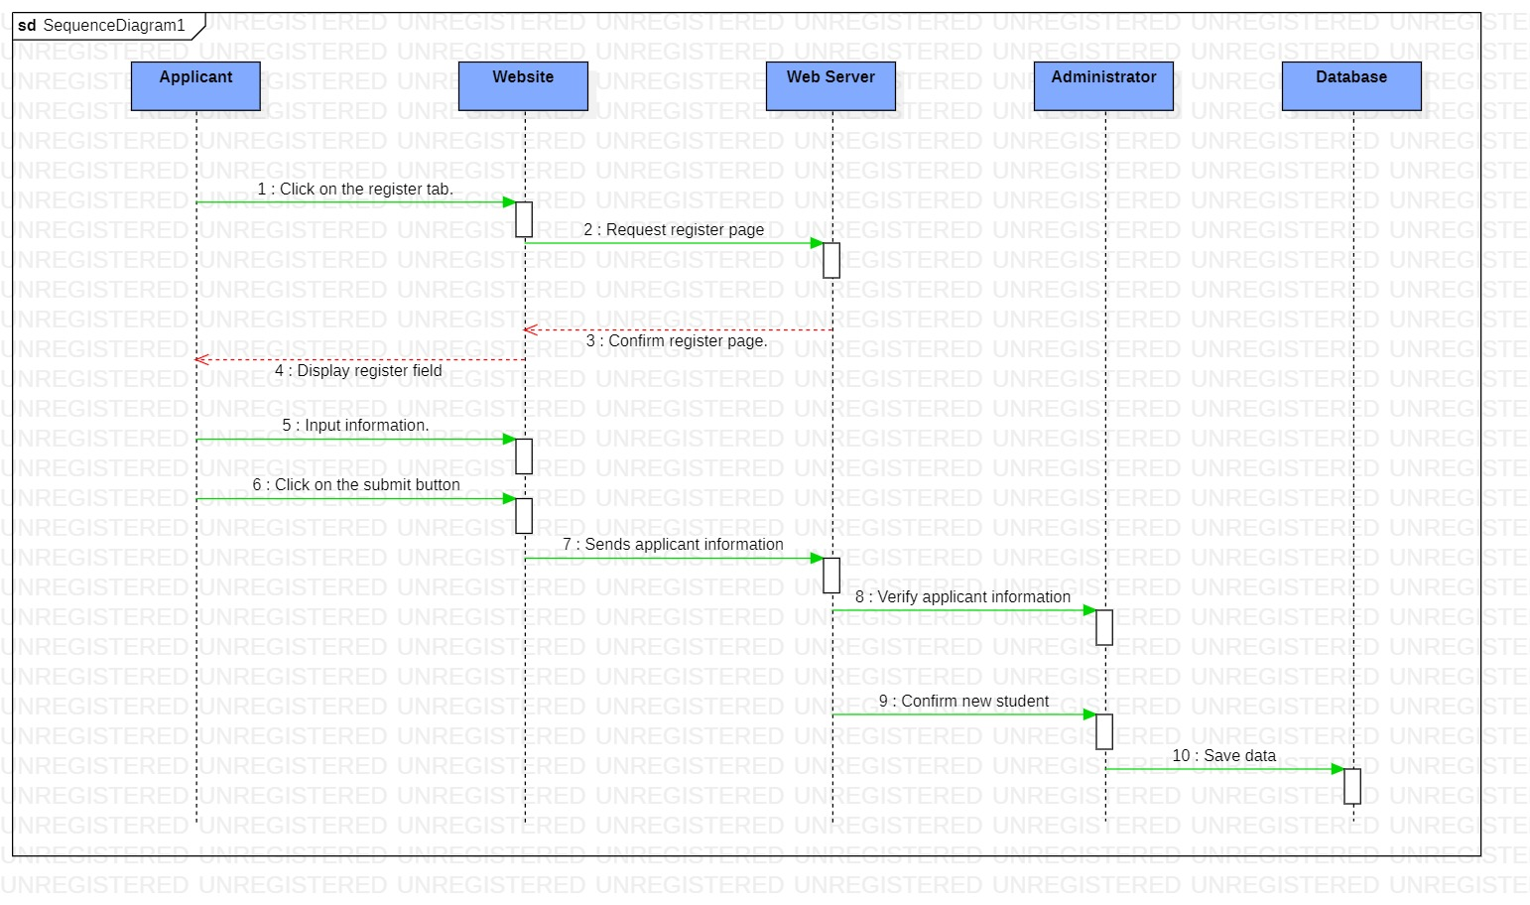

# **6. Database Design**

## **6.1 Table Student**

|  |  |  |  |
| --- | --- | --- | --- |
| **Attributes** | **Data Type** | **Field Size** | **Constraints** |
| StudentID | Varchar | 14 | Primary key |
| StudentName | Varchar | 50 | Not null |
| StudentDOB | Date | 7 | Not null |
| StudentEmail | Varchar | 50 | Not null |
| StudentAddress | Varchar | 100 | Not null |
|  |  |  |  |
| StudentGender | Varchar | 15 | Not null |
| Cohort | Varchar | 10 | Foreign key |
| AttendanceID | Varchar | 15 | Foreign key |
| ProgrammeID | Varchar | 10 | Foreign key |
| ModuleID | Varchar | 10 | Foreign key |
|  |  |  |  |
| CourseworkID | Varchar | 15 | Foreign key |
| ResitCourseworkID | Varchar | 15 | Foreign key |
| ExamID | Varchar | 15 | Foreign key |
| ResitExamID | Varchar | 15 | Foreign key |
| ProjectID | Varchar | 15 | Foreign key |
|  |  |  |  |
| ResitProjectID | Varchar | 15 | Foreign key |
| PaymentID | Varchar | 15 | Foreign key |
| WorkPlacementID | Varchar | 15 | Foreign key |
| AccountID | Varchar | 10 | Foreign key |
| Result | Varchar | 250 | Foreign key |

## **6.2 Table Programme**

|  |  |  |  |
| --- | --- | --- | --- |
| **Attributes** | **Data Type** | **Field Size** | **Constraints** |
| ProgrammeID | Varchar | 10 | Primary key |
| ProgrammeName | Varchar | 100 | Not null |
| ProgrammeDuration | Varchar | 10 | Not null |
| ProgrammeCoordinatorID | Varchar | 14 | Foreign key |
| LecturerID | Varchar | 14 | Foreign key |
|  |  |  |  |
| ModuleID | Varchar | 10 | Foreign key |
| StudentID | Varchar | 14 | Foreign key |
| Cohort | Varchar | 10 | Foreign key |
| WorkPlacementID | Varchar | 15 | Foreign key |

## **6.3 Table Programme Coordinator**

|  |  |  |  |
| --- | --- | --- | --- |
| **Attributes** | **Data Type** | **Field Size** | **Constraints** |
| ProgrammeCoordinatorID | Varchar | 14 | Primary key |
| ProgrammeCoordinatorName | Varchar | 50 | Not null |
| ProgrammeCoordinatorAddress | Varchar | 100 | Not null |
| ProgrammeCoordinatorDOB | Date | 7 | Not null |
| ProgrammeCoordinatorGender | Varchar | 15 | Not null |
|  |  |  |  |
| ProgrammeCoordinatorMobileNumber | Number | 12 | Not null |
| ProgrammeCoordinatorEmail | Varchar | 50 | Not null |
| AccountID | Varchar | 10 | Foreign key |
| ProgrammeID | Varchar | 10 | Foreign key |

## **6.4 Table Module**

|  |  |  |  |
| --- | --- | --- | --- |
| **Attributes** | **Data Type** | **Field Size** | **Constraints** |
| ModuleID | Varchar | 10 | Primary key |
| ModuleName | Varchar | 100 | Not null |
| ModuleDuration | Varchar | 10 | Not null |
| ModuleCoordinatorID | Varchar | 14 | Foreign key |
| LecturerID | Varchar | 14 | Foreign key |
|  |  |  |  |
| StudentID | Varchar | 14 | Foreign key |
| Cohort | Varchar | 10 | Foreign key |
| ProgrammeID | Varchar | 10 | Foreign key |
| ProgrammeCoordinatorID | Varchar | 14 | Foreign key |
| ModuleGPA | Nvarchar | 5 | Not null |
|  |  |  |  |
| CourseworkID | Varchar | 15 | Foreign key |
| ResitCourseworkID | Varchar | 15 | Foreign key |
| ExamID | Varchar | 15 | Foreign key |
| ResitExamID | Varchar | 15 | Foreign key |
| ProjectID | Varchar | 15 | Foreign key |
| ResitProjectID | Varchar | 15 | Foreign key |

## **6.5 Table Module Coordinator**

|  |  |  |  |
| --- | --- | --- | --- |
| **Attributes** | **Data Type** | **Field Size** | **Constraints** |
| ModuleCoordinatorID | Varchar | 14 | Primary key |
| ModuleCoordinatorName | Varchar | 50 | Not null |
| ModuleCoordinatorAddress | Varchar | 100 | Not null |
| ModuleCoordinatorDOB | Date | 7 | Not null |
| ModuleCoordinatorGender | Varchar | 15 | Not null |
|  |  |  |  |
| ModuleCoordinatorEmail | Varchar | 50 | Not null |
| ModuleCoordinaorMobileNumber | Number | 12 | Not null |
| ModuleID | Varchar | 10 | Foreign key |
| ProgrammeID | Varchar | 10 | Foreign key |
| AccountID | Varchar | 10 | Foreign key |

## **6.6 Table Cohort**

|  |  |  |  |
| --- | --- | --- | --- |
| **Attributes** | **Data Type** | **Field Size** | **Constraints** |
| Cohort | Varchar | 10 | Primary key |
| YearStart | Number | 4 | Not null |
| YearEnd | Number | 4 | Not null |
| StudentID | Varchar | 14 | Foreign key |
| ProgrammeID | Varchar | 10 | Foreign key |
| ModuleID | Varchar | 10 | Foreign key |

## **6.7 Table Lecturer**

|  |  |  |  |
| --- | --- | --- | --- |
| **Attributes** | **Data Type** | **Field Size** | **Constraints** |
| LecturerID | Varchar | 14 | Primary key |
| LecturerName | Varchar | 50 | Not null |
| LecturerGender | Varchar | 15 | Not null |
| LecturerDOB | Date | 7 | Not null |
| LecturerAddress | Varchar | 100 | Not null |
|  |  |  |  |
| LecturerMobileNumber | Number | 12 | Not null |
| LecturerEmail | Varchar | 50 | Not null |
| AttendanceID | Varchar | 15 | Foreign key |
| ProgrammeCoordinatorID | Varchar | 14 | Foreign key |
| ModuleCoordinatorID | Varchar | 14 | Foreign key |
|  |  |  |  |
| CourseworkID | Varchar | 15 | Foreign key |
| ResitCourseworkID | Varchar | 15 | Foreign key |
| ProjectID | Varchar | 15 | Foreign key |
| ResitProjectID | Varchar | 15 | Foreign key |
| AccountID | Varchar | 10 | Foreign key |

|  |  |  |  |
| --- | --- | --- | --- |
| **Attributes** | **Data Type** | **Field Size** | **Constraints** |
| CourseworkID | Varchar | 15 | Primary key |
| CourseworkName | Varchar | 100 | Not null |
| CourseworkStartline | Varchar | 15 | Not null |
| CourseworkDeadline | Varchar | 15 | Not null |
| CourseworkGrade | Char | 1 | Not null |
|  |  |  |  |
| LecturerID | Varchar | 14 | Foreign key |
| StudentID | Varchar | 14 | Foreign key |
| Cohort | Varchar | 10 | Foreign key |
| ModuleID | Varchar | 10 | Foreign key |
| ProgrammeID | Varchar | 10 | Foreign key |
| ModuleCoordinatorID | Varchar | 14 | Foreign key |
| ModeratedCourseworkReview | Varchar | 250 | Null |

## **6.8 Table Coursework**

## **6.9 Table Re-sit Coursework**

|  |  |  |  |
| --- | --- | --- | --- |
| **Attributes** | **Data Type** | **Field Size** | **Constraints** |
| ResitCourseworkID | Varchar | 15 | Primary key |
| ResitCourseworkName | Varchar | 100 | Not null |
| ResitCourseworkStartline | Varchar | 15 | Not null |
| ResitCourseworkDeadline | Varchar | 15 | Not null |
| ResitCourseworkGrade | Char | 1 | Null |
|  |  |  |  |
| StudentID | Varchar | 14 | Foreign key |
| Cohort | Varchar | 10 | Foreign key |
| LecturerID | Varchar | 14 | Foreign key |
| ModuleID | Varchar | 10 | Foreign key |
| ModuleCoordinatorID | Varchar | 14 | Foreign key |
| ProgrammeID | Varchar | 10 | Foreign key |

## **6.10 Table Exam**

|  |  |  |  |
| --- | --- | --- | --- |
| **Attributes** | **Data Type** | **Field Size** | **Constraints** |
| ExamID | Varchar | 15 | Primary key |
| ExamName | Varchar | 100 | Not null |
| ExamDuration | Varchar | 10 | Not null |
| ExamStartDate | Date | 7 | Not null |
| ExamEndDate | Date | 7 | Not null |
|  |  |  |  |
| ProgrammeID | Varchar | 10 | Foreign key |
| ModuleID | Varchar | 10 | Foreign key |
| ModuleCoordinatorID | Varchar | 14 | Foreign key |
| ProgrammeCoordinatorID | Varchar | 14 | Foreign key |
| Cohort | Varchar | 10 | Foreign key |
|  |  |  |  |
| StudentID | Varchar | 14 | Foreign key |
| ExamGrade | Char | 1 | Not null |
| ModeratedExaminationReview | Varchar | 250 | Null |

## **6.11 Table Re-sit Exam**

|  |  |  |  |
| --- | --- | --- | --- |
| **Attributes** | **Data Type** | **Field Size** | **Constraints** |
| ResitExamID | Varchar | 15 | Primary key |
| ResitExamName | Varchar | 100 | Not null |
| ResitExamDuration | Varchar | 10 | Not null |
| ResitExamStartDate | Date | 7 | Not null |
| ResitExamEndDate | Date | 7 | Not null |
|  |  |  |  |
| Cohort | Varchar | 10 | Foreign key |
| StudentID | Varchar | 14 | Foreign key |
| ProgrammeID | Varchar | 10 | Foreign key |
| ProgrammeCoordinatorID | Varchar | 14 | Foreign key |
| ModuleID | Varchar | 10 | Foreign key |
| ModuleCoordinatorID | Varchar | 14 | Foreign key |
| ResitExamGrade | Char | 1 | Null |

## **6.12 Table Project**

|  |  |  |  |
| --- | --- | --- | --- |
| **Attributes** | **Data Type** | **Field Size** | **Constraints** |
| ProjectID | Varchar | 15 | Primary key |
| ProjectName | Varchar | 100 | Not null |
| ProjectStartline | Varchar | 15 | Not null |
| ProjectDeadline | Varchar | 15 | Not null |
| ProgrammeID | Varchar | 10 | Foreign key |
|  |  |  |  |
| ModuleID | Varchar | 10 | Foreign key |
| ModuleCoordinatorID | Varchar | 14 | Foreign key |
| LecturerID | Varchar | 14 | Foreign key |
| Cohort | Varchar | 10 | Foreign key |
| StudentID | Varchar | 14 | Foreign key |
| ProjectGrade | Char | 1 | Not null |
| ModeratedProjectReview | Varchar | 250 | Null |

## **6.13 Table Re-sit Project**

|  |  |  |  |
| --- | --- | --- | --- |
| **Attributes** | **Data Type** | **Field Size** | **Constraints** |
| ResitProjectID | Varchar | 15 | Primary key |
| ResitProjectName | Varchar | 100 | Not null |
| ResitProjectStartline | Varchar | 15 | Not null |
| ResitProjectDeadline | Varchar | 15 | Not null |
| ProgrammeID | Varchar | 10 | Foreign key |
|  |  |  |  |
| ModuleID | Varchar | 10 | Foreign key |
| ModuleCoordinatorID | Varchar | 14 | Foreign key |
| LecturerID | Varchar | 14 | Foreign key |
| Cohort | Varchar | 10 | Foreign key |
| StudentID | Varchar | 14 | Foreign key |
| ResitProjectGrade | Char | 1 | Null |

## **6.14 Table Work Placement**

|  |  |  |  |
| --- | --- | --- | --- |
| **Attributes** | **Data Type** | **Field Size** | **Constraints** |
| WorkPlacementID | Varchar | 15 | Primary key |
| WorkPlacementName | Varchar | 100 | Not null |
| WorkPlacementAddress | Varchar | 100 | Not null |
| WorkPlacementStartingDate | Date | 7 | Not null |
| WorkPlacementEndingDate | Date | 7 | Not null |
|  |  |  |  |
| ProgrammeID | Varchar | 10 | Foreign key |
| ProgrammeCoordinatorID | Varchar | 14 | Foreign key |
| Cohort | Varchar | 10 | Foreign key |
| StudentID | Varchar | 14 | Foreign key |
| WorkPlacementReview | Varchar | 250 | Null |

## **6.15 Table Board of Examiners**

|  |  |  |  |
| --- | --- | --- | --- |
| **Attributes** | **Data Type** | **Field Size** | **Constraints** |
| BOE_ID | Varchar | 10 | Primary key |
| ProgrammeID | Varchar | 10 | Foreign key |
| ProgrammeCoordinatorID | Varchar | 14 | Foreign key |
| ModuleID | Varchar | 10 | Foreign key |
| ModuleCoordinatorID | Varchar | 14 | Foreign key |

## **6.16 Table Result**

|  |  |  |  |
| --- | --- | --- | --- |
| **Attributes** | **Data Type** | **Field Size** | **Constraints** |
| Result | Varchar | 250 | Primary key |
| Cohort | Varchar | 10 | Foreign key |
| StudentID | Varchar | 14 | Foreign key |
| ProgrammeID | Varchar | 10 | Foreign key |
| CourseworkID | Varchar | 15 | Foreign key |
|  |  |  |  |
| ResitCourseworkID | Varchar | 15 | Foreign key |
| ExamID | Varchar | 15 | Foreign key |
| ResitExamID | Varchar | 15 | Foreign key |
| ProjectID | Varchar | 15 | Foreign key |
| ResitProjectID | Varchar | 15 | Foreign key |
| TranscriptName | Varchar | 250 | Not null |

## **6.17 Table Attendance**

|  |  |  |  |
| --- | --- | --- | --- |
| **Attributes** | **Data Type** | **Field Size** | **Constraints** |
| AttendanceID | Varchar | 15 | Primary key |
| Cohort | Varchar | 10 | Foreign key |
| NumOfStudents | Number | 3 | Not null |
| StudentID | Varchar | 14 | Foreign key |
| Absent/Present | Varchar | 7 | Not null |
|  |  |  |  |
| WeekNo | Number | 2 | Not null |
| ProgrammeID | Varchar | 10 | Foreign key |
| ModuleID | Varchar | 10 | Foreign key |
| ModuleCoordinatorID | Varchar | 14 | Foreign key |
| LecturerID | Varchar | 14 | Foreign key |
| Remarks | Varchar | 250 | Null |

## **6.18 Table Account**

|  |  |  |  |
| --- | --- | --- | --- |
| **Attributes** | **Data Type** | **Field Size** | **Constraints** |
| AccountID | Varchar | 10 | Primary key |
| AccountName | Varchar | 50 | Not null |
| StudentID | Varchar | 14 | Foreign key |
| ProgrammeCoordinatorID | Varchar | 14 | Foreign key |
| ModuleCoordinatorID | Varchar | 14 | Foreign key |
| LecturerID | Varchar | 14 | Foreign key |
| AdmissionID | Varchar | 10 | Foreign key |

## **6.19 Table Applicant**

|  |  |  |  |
| --- | --- | --- | --- |
| **Attributes** | **Data Type** | **Field Size** | **Constraints** |
| ApplicantID | Varchar | 14 | Primary key |
| ApplicantName | Varchar | 50 | Not null |
| ApplicantDOB | Date | 7 | Not null |
| ApplicantGender | Varchar | 15 | Not null |
| ApplicantEmail | Varchar | 100 | Not null |
|  |  |  |  |
| ApplicantContactNo | Number | 12 | Not null |
| ApplicantAddress | Varchar | 100 | Not null |
| ApplicantDocs | Varchar | 50 | Not null |
| ApplicantStatus | Varchar | 50 | Not null |
| PaymentID | Varchar | 15 | Foreign key |

## **6.20 Table Admission**

|  |  |  |  |
| --- | --- | --- | --- |
| **Attributes** | **Data Type** | **Field Size** | **Constraints** |
| AdmissionID | Varchar | 10 | Primary key |
| AdmissionDate | Date | 7 | Not null |
| NoOfDocScanned | Number | 2 | Not null |
| AccountID | Varchar | 10 | Foreign key |
| ApplicantID | Varchar | 14 | Foreign key |
|  |  |  |  |
| AdmissionStatus | Varchar | 50 | Not null |
| MeritStatusTracking | Varchar | 50 | Not null |
| QualifyingScores | Number | 2 | Not null |
| MeritList | Varchar | 250 | Not null |

## **6.21 Table Payment**

|  |  |  |  |
| --- | --- | --- | --- |
| **Attributes** | **Data Type** | **Field Size** | **Constraints** |
| PaymentID | Varchar | 15 | Primary key |
| PaymentDate | Date | 7 | Not null |
| StudentID | Varchar | 14 | Foreign key |
| Cohort | Varchar | 10 | Foreign key |
| AccountID | Varchar | 10 | Foreign key |
|  |  |  |  |
| ApplicantID | Varchar | 14 | Foreign key |
| PaymentMethod | Varchar | 20 | Not null |
| FeesPaid | Number | 6 | Not null |
| FeesDue | Number | 6 | Not null |

# **7. Input and output Designs**

## **7.1 Registration**

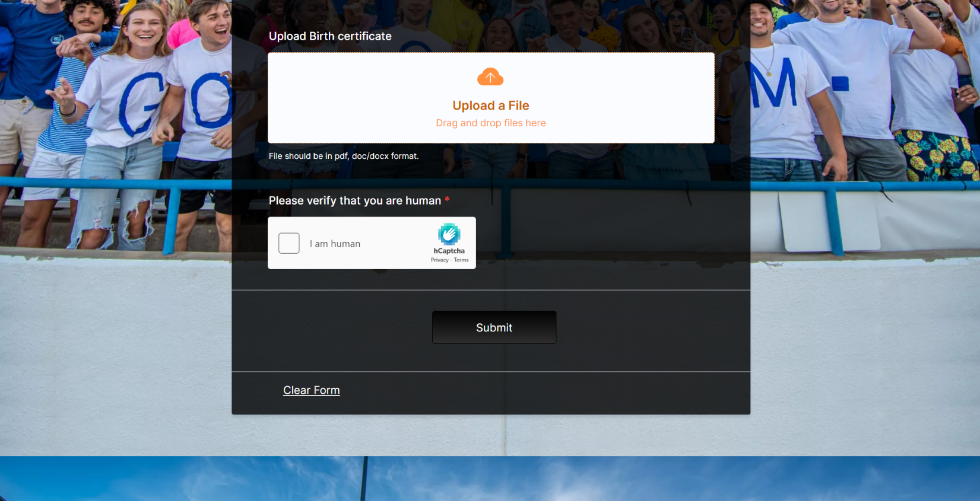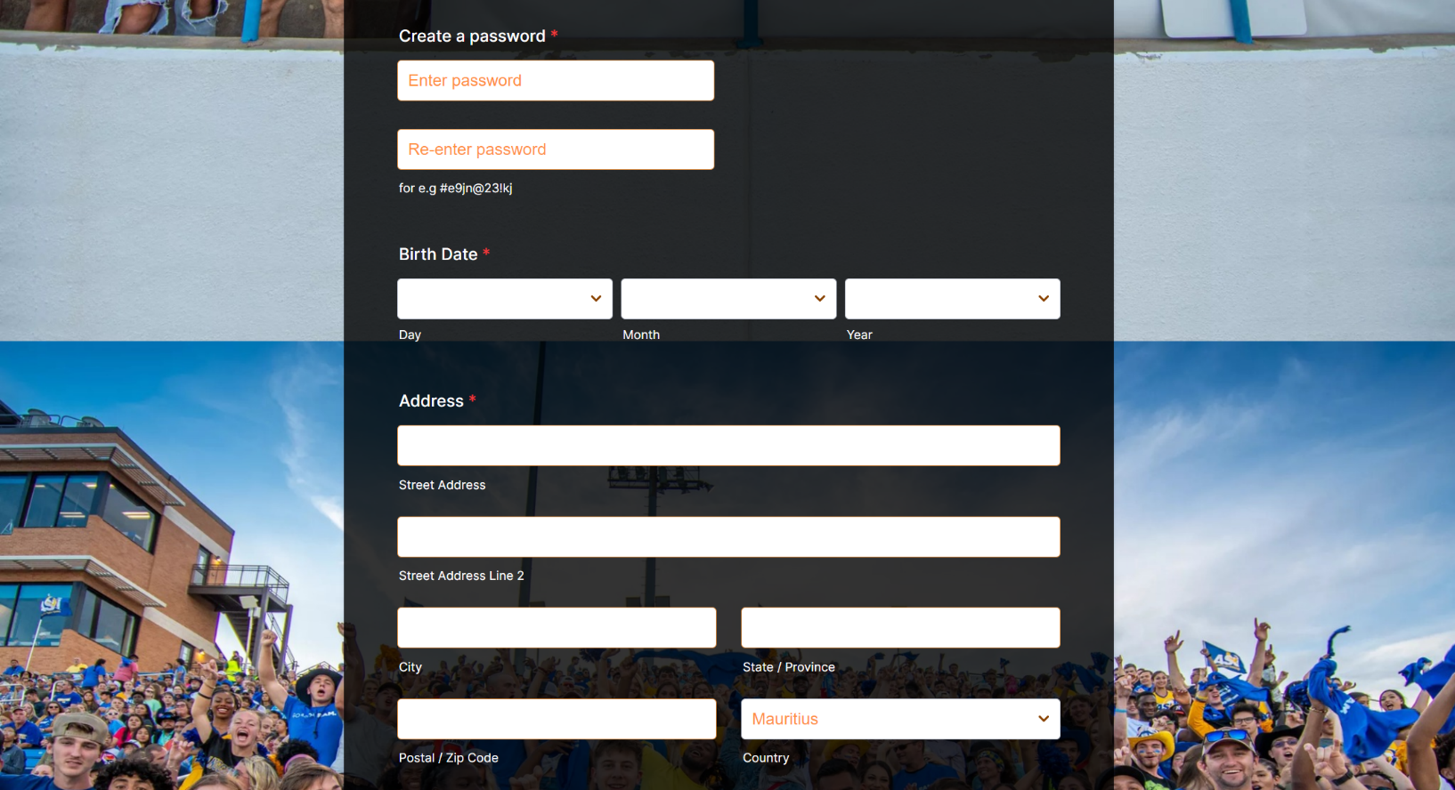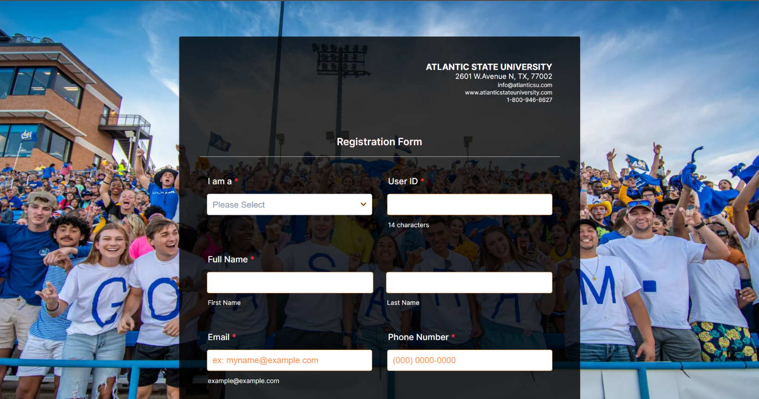

Description: Users such as Lecturer, Student, Administrator, Programme Coordinator, Module Coordinator, Applicant can create and account and register themselves.

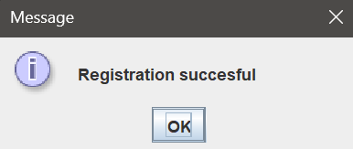

Description: User was able to register successfully.

## **7.2 Login**

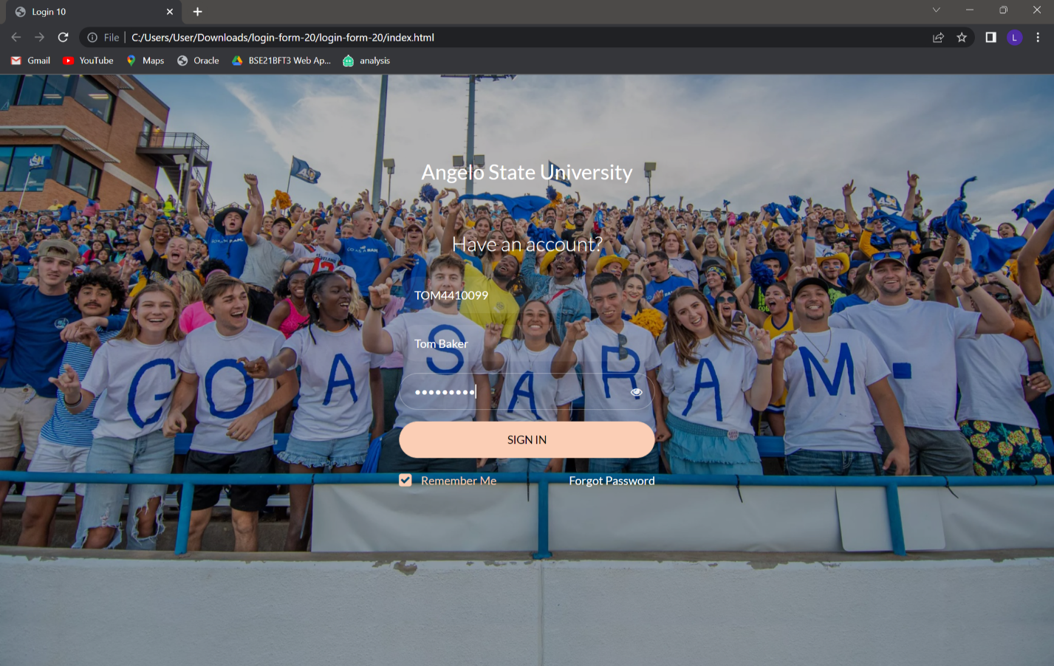

Description: Users log into their account using their account ID.

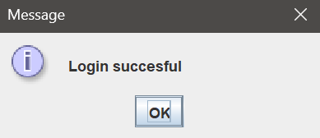

Description: User was able to log into their account successfully.

View Login form

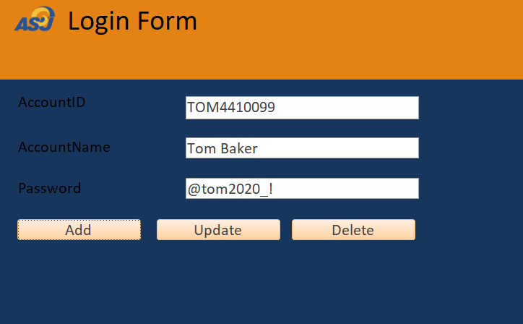

Description: Details can be added, updated, and deleted.

## **7.3 Admission**



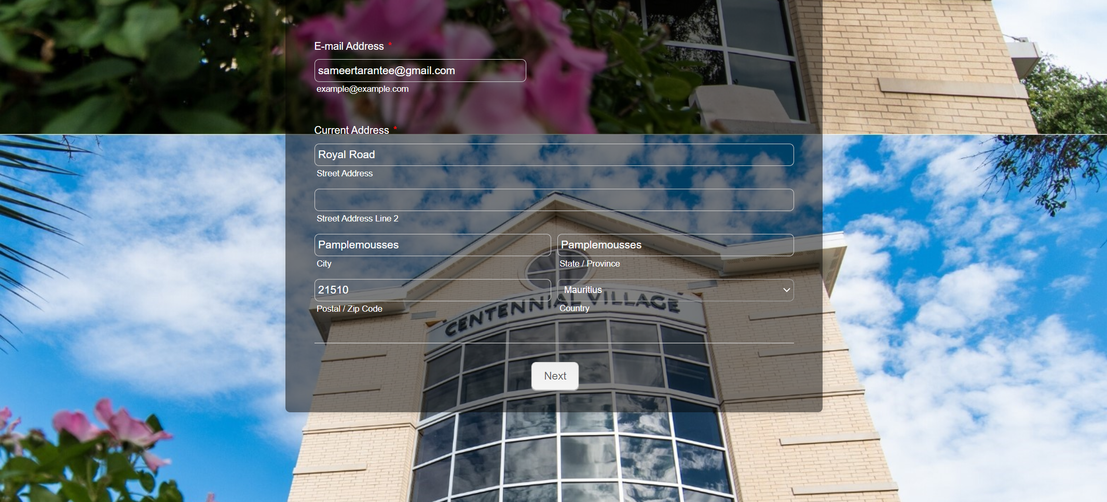

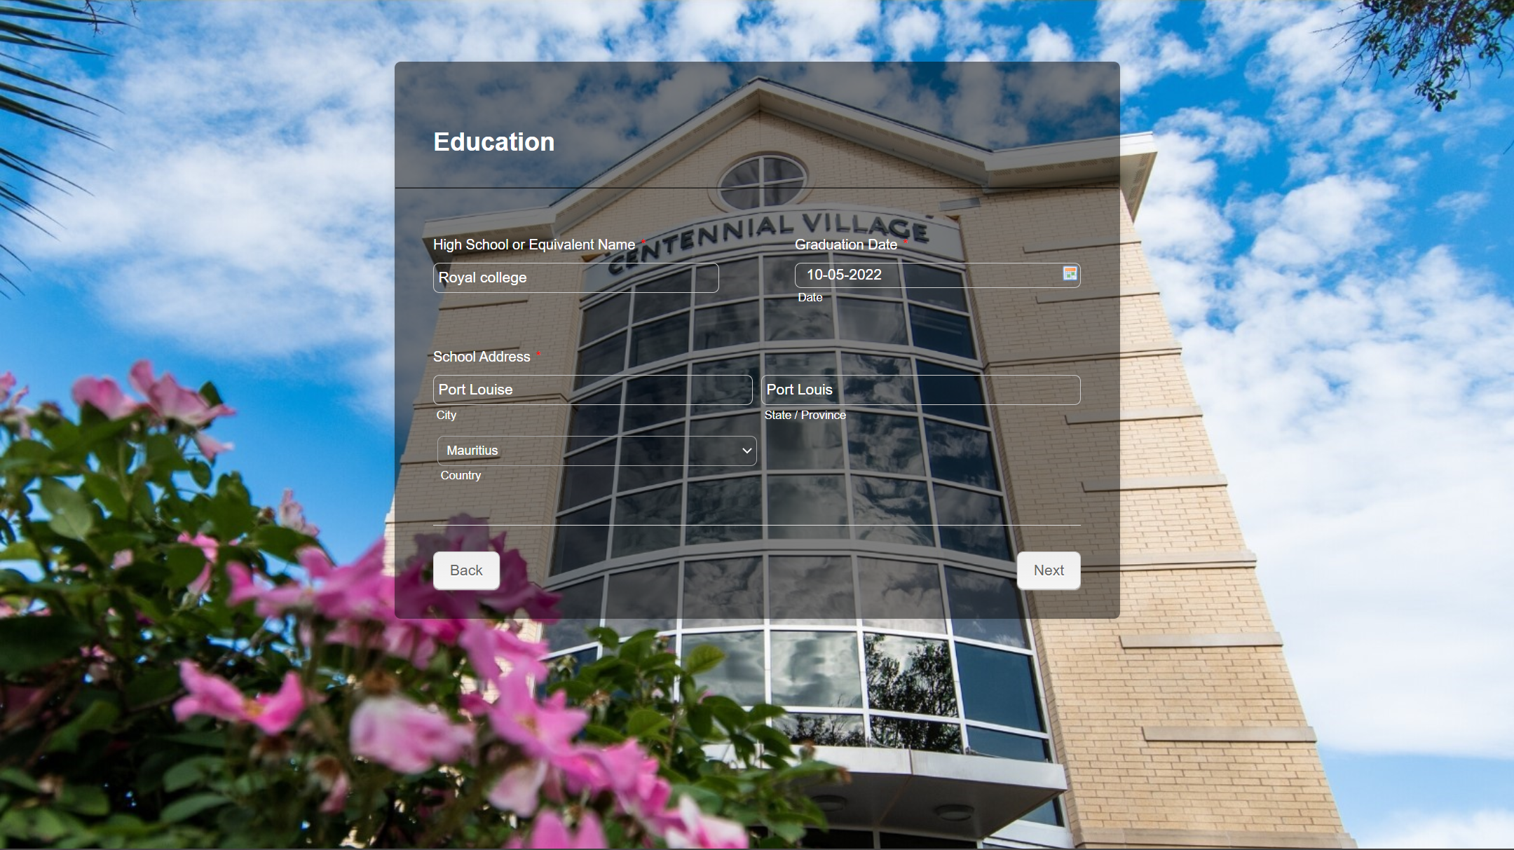

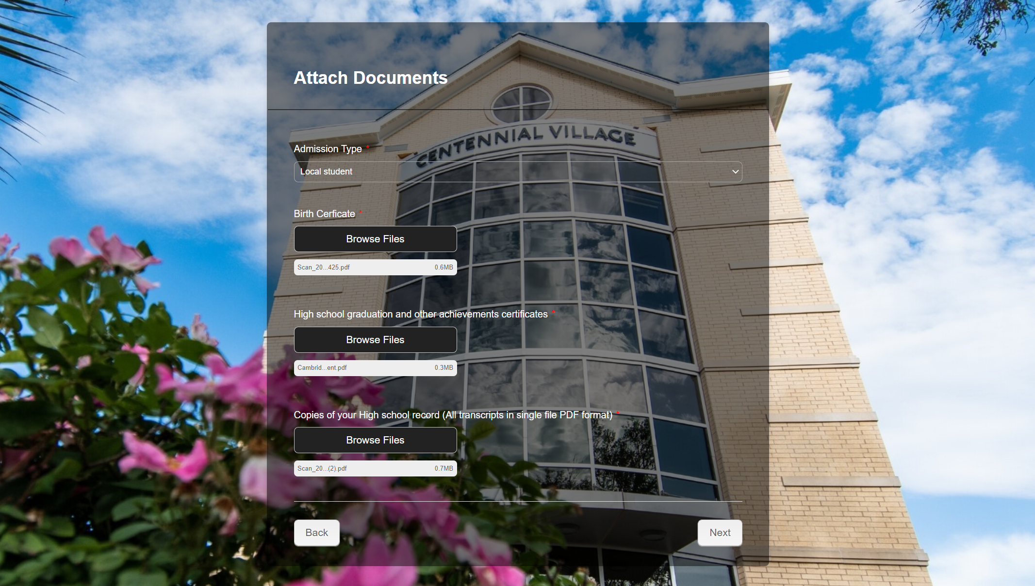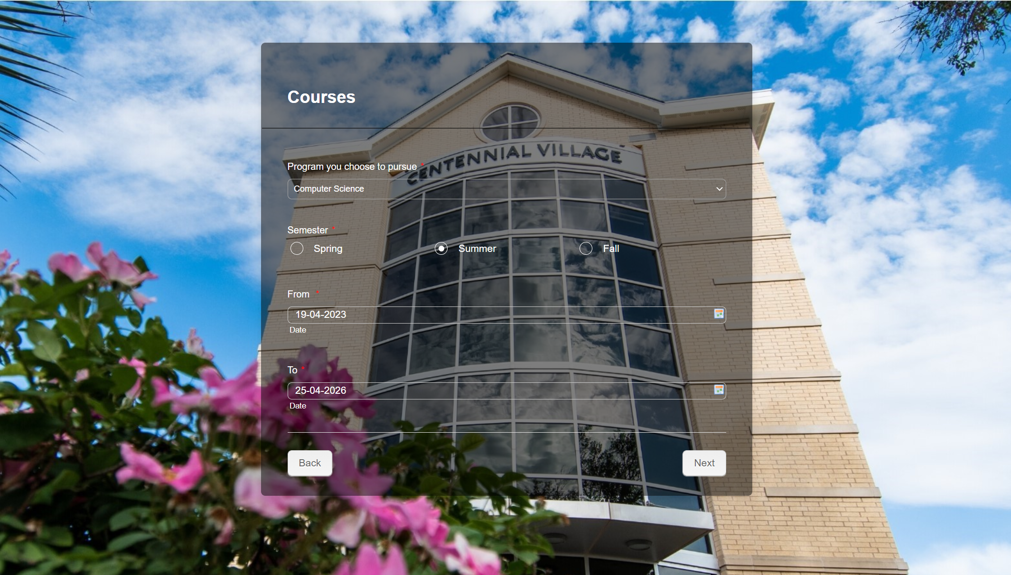

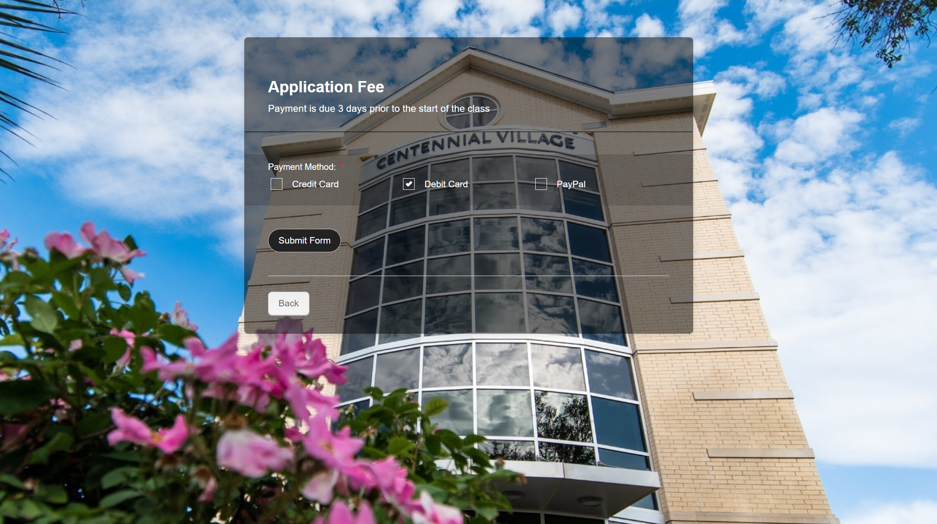



Description: Applicants fill out admission form and submit.

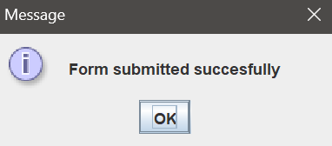

Description: Admission form submitted successfully.

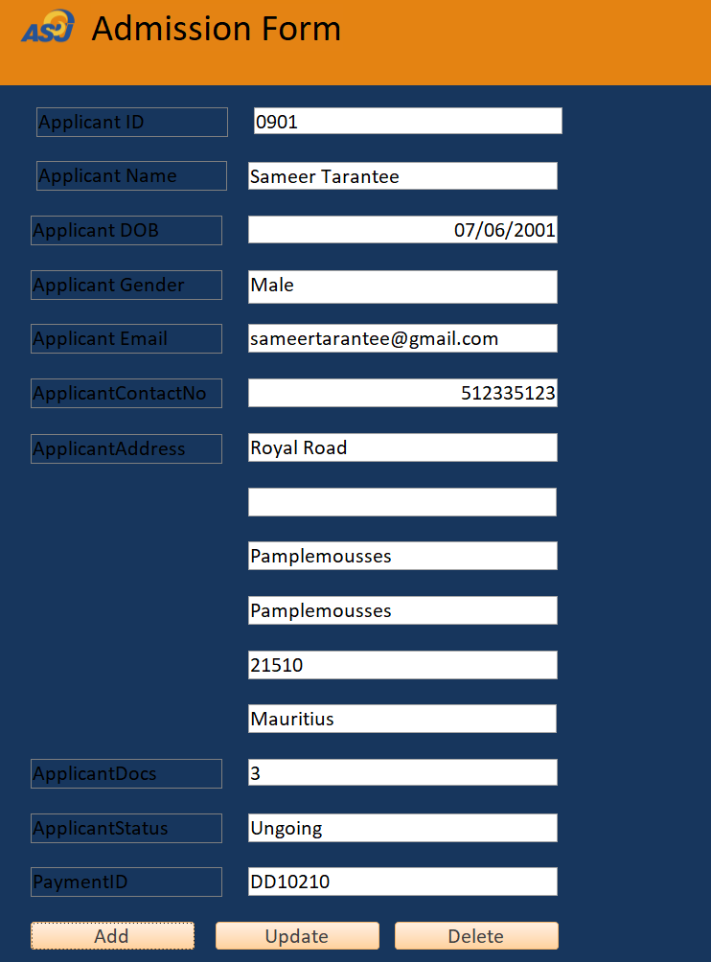

Description: Application form details can be added, updated, and deleted.

## **7.4 Coursework**

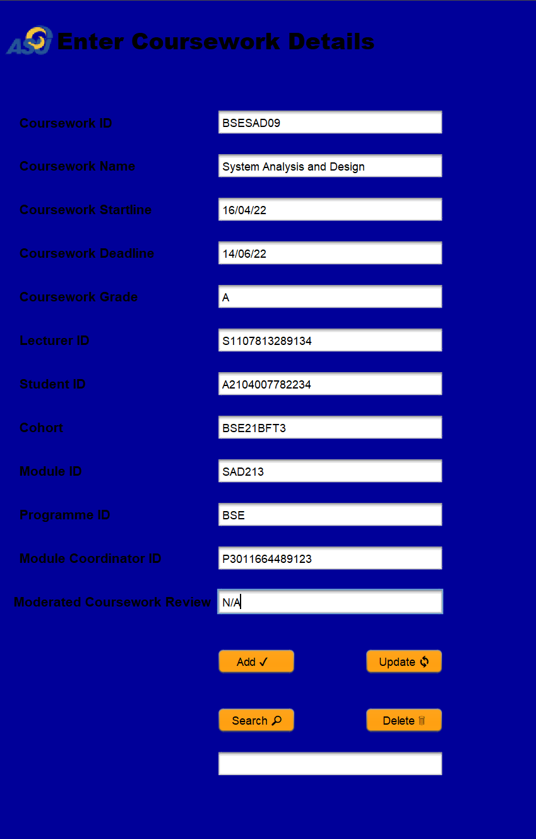

Description: We have entered coursework details. Records can be updated, deleted, and searched.

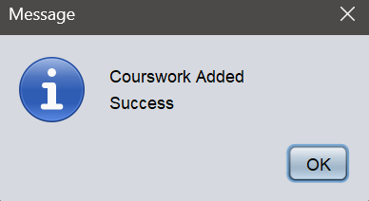

Add coursework

Description: Coursework has been added successfully.

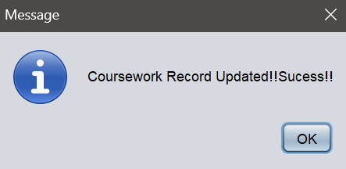

Update coursework

Description: Coursework has been updated

successfully.

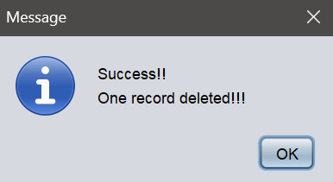

Delete coursework

Description: Coursework has been deleted

successfully.

View coursework

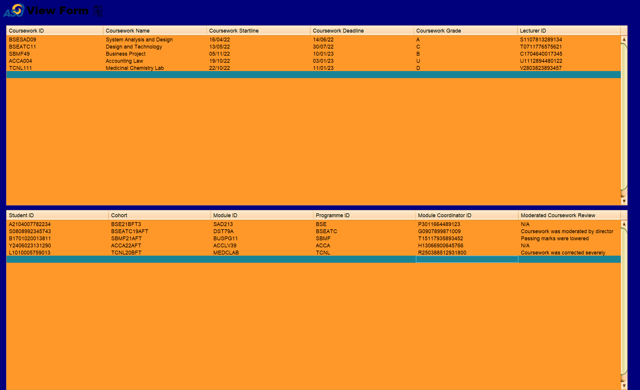

Description: We can view the complete list we have entered of coursework details.

# **8. Testing**

Software testing is a very essential aspect that forms part in the software development cycle. The testing demonstrate the Quality of the software developed and reflects the ultimate view of specification, design, and coding. Software testing is known as the process through which one can inspect anomalies in the software program. Testing is a set of activities that work towards the integration of an entire computer-based system.

Testing Objectives:

1. Efficient testing helps preventing defects and that helps in provided an error-free application

2. To evaluate work products such as requirements, user stories, design, and code

3. To find failures and defects. Defects should be primarily identified exceedingly early in the test cycle

4. To check whether all mentioned requirements have been fulfilled

5.To make informed decisions, especially regarding the level of quality of the test object

6. To validate whether the test object is completed and works as the users and other stakeholders expect

7. To reduce the level of risk of inadequate software quality

8. To build confidence in the level of quality of the test object

## **8.1 White Box Testing**

White-box testing techniques analyse the internal architecture, the data structures used, the internal design, the code structure, and the behaviour of the software, in addition to functionality like black-box testing.

Software development can be tested at the system, integration, and unit levels. Verifying that an application's working flow is one of White box testing's fundamental objectives. It is comparing a sequence of specified inputs to desired or expected outputs to identify bugs when a particular input does not provide the desired outcome.

## **8.2 Black Box Testing**

Black box testing entails evaluating a system without being aware of how it operates within. A tester enters data and analyze the output produced by the system being tested. This allows for the identification of the system's response time, usability difficulties, and reliability concerns as well as how the system reacts to expected and unexpected user activities.

Since it tests a system from the start until the end, black box testing is said to be a redoubtable testing method. A tester can imitate user action to check whether the system fulfills its promises, much as end users "don't care" how a system is programmed or designed and expect to get a suitable response to their requests. A black box test checks all pertinent subsystems along the route, including UI/UX, the web server or application server, the database, dependencies, and integrated systems.

## **8.3 Unit Testing**

Individual software components or components are tested as part of a type of software testing known as unit testing. The goal is to confirm that each piece of software code operates as intended. Developers perform unit testing while creating an application (the coding phase). Unit tests isolate a specific piece of code and confirm its accuracy. A singular function, method, procedure, module, or object might be considered a unit.

Unit testing is the first level of testing carried out prior to integration testing in the SDLC, STLC, and V Model. Unit testing is a type of White Box testing that is often carried out by the developer. However, in the real world, QA engineers also perform unit testing because of time constraints or developers' resistance to testing.

## **8.4 Integration Testing**

Software components are logically connected and tested as a unit in a type of testing called integration testing. Multiple software modules created by various programmers make up a typical software project. This level of testing's objective is to find issues with how various software modules interact when they are combined.

The main goal of integration testing is to examine how effectively these modules communicate data. The name "I & T" (Integration and Testing), "String Testing," and occasionally "Thread Testing" are also used to describe it.

# **9. Test Cases**

## **9.1 Registration form:**

|  |  |  |
| --- | --- | --- |
| **Test Case: First Name** | | |
| **Test Values** | **Result** | **Displayed error message** |
| Sarah | Correct | - |
| Sarah234 | Incorrect | Enter letters only |
| Sarah/* | Incorrect | Enter letters only |

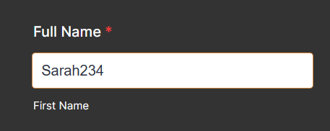

Enter letters only!

|  |  |  |
| --- | --- | --- |
| **Test Case: Last Name** | | |
| **Test Values** | **Result** | **Displayed error message** |
| Jones | Correct | - |
| Jones234 | Incorrect | Enter letters only |
| Jones/* | Incorrect | Enter letters only |

|  |  |  |
| --- | --- | --- |
| **Test Case: Phone Number** | | |
| **Test Values** | **Result** | **Displayed error message** |
| (123) 4561-2344 | Correct | - |
| (230)4561-23ab | Incorrect | System does not display anything when letters are added |

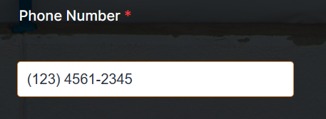

|  |  |  |
| --- | --- | --- |
| **Test Case: Email** | | |
| **Test Values** | **Result** | **Displayed error message** |
| SarahJones@gmail.com | Correct | - |
| Sarah1234.com | Incorrect | Enter a valid email address |
| @gmail.comsarah | Incorrect | Enter a valid email address |

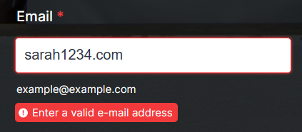

|  |  |  |
| --- | --- | --- |
| **Test Case: Password** | | |
| **Test Values** | **Result** | **Displayed error message** |
| Enter Password: SarahJones024 | Correct | - |
| Re-enter Password: SarahJones024 | Correct | - |
| Enter Password: SarahJones024 | Incorrect | - |
| Re-enter Password: SarahJnoes024 | Incorrect | Password does not match! |

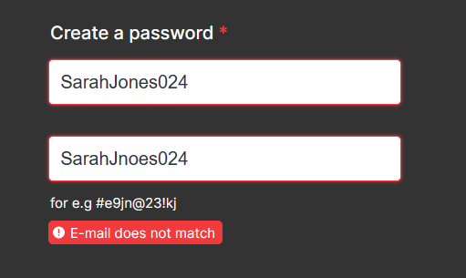

Password does not match!

|  |  |  |
| --- | --- | --- |
| **Test Case: Upload Birth Certificate** | | |
| **Test Values** | **Result** | **Displayed error message** |
| File with pdf, doc extension | Correct | - |
| File with png extension | Incorrect | File has an invalid extension  Only pdf, doc, docx are allowed |

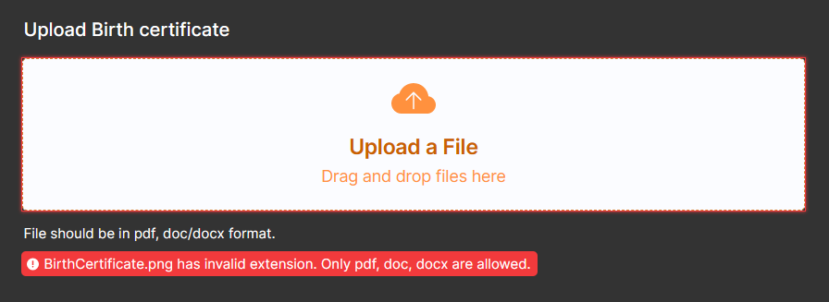

# **10. Gantt Chart**

# **11.** **Conclusion**

To summarize everything, the idea behind this management system consists of mainly to reduce the exhaustive burden of admission and administrative paperwork. This new concept makes the jobs of all the system users much easier and also a little enjoyable compared to the old manual system. An effective and a proper student management system is so fundamental for the success of tertiary educational establishments. Nowadays, with the increasing number of students enrolments, most of the institutions tend to stick to the student management system to improve operational efficiency and encourage students’ overall experience throughout their journeys!